Tab 1

Financial Advisor App for Students

Camille Embree, Hoang-Nghi Nguyen

**Final Report**

**Table of Contents**

**1. Concept of Operations 3**

**2. Functional System Requirements** **27**

**3. Interface Control Document 43**

**4. Schedule and Validation 51**

**5. Frontend Subsystem Report 58**

**5. Backend Subsystem Report 70**

**6. Full System Report 94**

Financial Advisor App for Students

Camille Embree, Hoang-Nghi Nguyen

**Concept of Operations**

REVISION – 3

7 December 2025

Concept of Operations

for

Financial Advisor App for Students

Team <27>

Approved by:

_____________________________

Project Leader Date

_____________________________

Prof. Nowka Date

_____________________________

T/A Date

**Change Record**

| **Rev.** | **Date** | **Originator** | **Approvals** | **Description** |
| --- | --- | --- | --- | --- |
| **1** | 2/5/2025 | Team 27 |  | Draft Release |
| **2** | 4/26/2025 | Hoang-Nghi Nguyen |  | Change in core features from first concept |
| **3** | 12/7/2025 | Hoang-Nghi Nguyen |  | Change in core features and fundamental functionality from second concept change. |

**Table of Contents**

**List of Figures 7**

**1. Executive Summary 8**

**2. Introduction 9**

2.1. Background 9

2.2. Overview 9

**3. Operating Concept 11**

3.1. Scope 11

3.2. Operational Description and Constraints 11

3.3. System Description 12

3.4. Modes of Operations 15

3.5. Users 17

3.6. Support 18

**4. Scenario(s)** **20**

4.1. First-Time User Sign-In and Account Setup 20

4.2. Transaction Synchronization and Dashboard Viewing  20

4.3. Playing Smart Saver Quiz  21

4.4. Playing Financial Categories  21

4.5. Playing Spend Detective  22

4.6. Viewing Progression and Profile  22

4.7. Error Handling and Constraint Conditions  23

**5. Analysis** **24**

5.1. Summary of Proposed Improvements 24

5.2. Disadvantages and Limitations 24

5.3. Alternatives 25

5.4. Impact 25

**List of Figures**

[**Figure 1.** Block Diagram of](https://docs.google.com/document/d/1HI3k-dRsa3aTesSoNpU5QRLBi3-OpZflQ-VpZdAasgM/edit#heading=h.1t3h5sf) System15

# 

# Executive Summary

The Personalized Financial Advisor project was developed to help students manage their personal finances more effectively through an intelligent, automated mobile application. The final system is centered around secure aggregation of bank transactions using Plaid, real-time spending analytics, and a set of gamified learning experiences. After a user links their bank account, the backend automatically pulls recent transactions, writes them into Firebase Firestore, and exposes analytics endpoints for aggregated spending, budget tracking, and trend visualization. The React Native frontend uses these endpoints to render spending graphs, category breakdowns, and progress indicators, as well as to drive three minigames: Smart Saver Quiz, Spend Detective, and Financial Categories, that challenge users to interpret their own data, spot unusual purchases, and reason about budgeting decisions. This combination of automated data ingestion, interactive analytics, and structured gameplay reduces the need for manual tracking while helping students build practical financial habits over time.

The mobile frontend is implemented in React Native, while the backend is a Python Flask service deployed on Google Cloud Run with Firebase Firestore as the primary database and Plaid as the transaction integration provider.

# Introduction

Learning to manage money is an essential skill that everybody should have the opportunity to improve on. It’s particularly important among younger generations who are just beginning their journey to financial independence. This document will outline the main functions of the Personalized Financial Advisor App for Students, a mobile application designed to gamify finances, tracking expenses, and providing financial advice in order to make the approach to finances comfortable for its users.

## Background

Budgeting and financial literacy remain significant challenges for college students, many of whom rely on highly manual methods such as spreadsheets, manual tracking, or irregular reviews of bank statements. These tools require consistent user effort, provide limited insight, and rarely encourage users to build long-term financial habits. A successful financial management solution for students must minimize manual input, surface spending patterns automatically, and offer guidance in a way that is both intuitive and engaging.

To address these issues, the final system integrates directly with users’ financial accounts through Plaid, allowing the application to securely retrieve real transaction data without requiring receipt uploads or manual categorization. The backend stores normalized transactions in Firebase Firestore and generates real-time analytics, including category-level spending summaries, time-series trends, and budget utilization metrics,. that are consumed by the React Native frontend. These analytics form the foundation for the app’s interactive “Games” environment, where users strengthen financial skills through targeted challenges.

The application includes three gamified learning modules: Smart Saver Quiz, Spend Detective, and Financial Categories, which reinforce concepts such as budgeting discipline, anomaly detection, and category awareness. Each game uses the user’s actual transaction data and contributes to a progression system that tracks experience points, levels, and weekly participation. This approach transforms routine financial management into an adaptive, feedback-driven learning experience rather than a passive review of static information.

## Overview

The Personalized Financial Advisor application provides students with an automated and interactive platform for monitoring spending, managing budgets, and improving financial literacy. After securely linking a bank account through Plaid, the app automatically retrieves the user’s recent transactions and stores them in Firebase Firestore. This enables the system to maintain an accurate and up-to-date view of the user’s financial activity without requiring manual receipt entry or consistent user-driven categorization.

The mobile frontend presents this information through intuitive dashboards, including a transaction feed, category breakdowns, trend graphs, and monthly budget progress indicators. These views are powered by backend analytics endpoints that aggregate transaction data in real time, allowing users to quickly understand where their money is going and how their spending patterns evolve over the course of a budgeting period.

A defining feature of the final system is its built-in gamified financial education environment. The application incorporates three interactive minigames: Smart Saver Quiz, Spend Detective, and Financial Categories, each designed to reinforce different aspects of financial decision-making. Smart Saver Quiz focuses on foundational budgeting and savings concepts; Financial Categories tests the user’s ability to recognize and classify spending behavior; and Spend Detective challenges users to identify anomalous or artificially injected transactions based on their recent history. Performance in these games contributes to a unified progression system that tracks experience points, levels, and weekly participation limits.

In earlier phases of development, the project emphasized receipt-based data ingestion and AI-generated financial feedback. While these features informed initial design directions, the deployed solution shifts toward a more scalable and automated architecture centered on Plaid-driven transaction retrieval, analytic summaries, and interactive learning modules. This refined approach provides users with continuous, personalized insights while making financial management more engaging and accessible.

# Operating Concept

## Scope

The scope of the Personalized Financial Advisor system encompasses the end-to-end functionality required to automatically collect user financial data, generate actionable insights, and deliver an interactive learning experience through mobile and backend services. The system includes a React Native mobile application, a Python Flask backend deployed on Google Cloud Run, and a Firebase Firestore database used for secure data storage and user state management.

The operational boundary of the system begins when a user links a financial account through Plaid. Once linked, the backend securely retrieves and normalizes transactions, stores them in Firestore, and exposes analytics that power the app’s budgeting and spending visualizations. Users interact with these insights through the mobile interface, which presents category summaries, trend graphs, and budget progress indicators derived directly from their up-to-date transaction history.

Within scope is the complete gamified financial education environment integrated into the app. This includes the Smart Saver Quiz, Financial Categories, and Spend Detective minigames, each leveraging real transaction data or curated financial-literacy questions to reinforce budgeting and decision-making skills. The backend controls all game logic, scoring, weekly lockouts, and a unified progression system that tracks user experience points and levels across the app.

## Operational Description and Constraints

The Personalized Financial Advisor system operates as an integrated workflow across the mobile frontend, backend services, and external financial-data providers. Its operation begins when a user authenticates through Firebase and links a bank account via Plaid. Once authorized, the backend exchanges the Plaid public token for a secure access token and uses it to retrieve the user’s most recent financial transactions. These transactions are normalized and stored in Firebase Firestore, forming the authoritative data source for all subsequent analytics and gameplay functions.

During routine use, the mobile application communicates with the Flask backend to request updated analytics and game content. The backend computes category-level spending summaries, aggregates transactions across configurable date ranges, and generates budget progress indicators. These outputs are returned to the frontend to populate visual dashboards, graphs, and spending insights. Users rely on this functionality to understand their financial behavior without manual entry or maintenance.

In parallel, the backend manages the operational logic for the system’s gamified components: Smart Saver Quiz, Financial Categories, and Spend Detective. Each game session is initiated by the user and driven by the backend state. The server generates questions or transaction scenarios, validates user responses, updates experience points and levels, and enforces gameplay constraints such as weekly cooldowns for Spend Detective. All game-related data, progress, attempts, outcomes, and timestamps, is stored in Firestore to ensure consistency across sessions and devices.

Several constraints govern system operation:

1. **Security and Compliance:** Communication with Plaid must follow industry-standard authentication and encryption requirements. The system must not store sensitive banking credentials; only Plaid access tokens and transaction data are retained. Firebase ID token verification is required for all protected routes to prevent unauthorized access to user financial data.
2. **Data Freshness:** Plaid imposes rate limits and update intervals on transaction retrieval. As a result, the system may not always reflect real-time financial activity, and the backend must handle cases where new transactions have not yet propagated to Plaid’s API.
3. **Resource and Cost Constraints:** Deployment on Google Cloud Run requires the backend to operate efficiently within container execution time limits and avoid unnecessary compute-intensive tasks. All analytics are intentionally kept lightweight to preserve responsiveness.
4. **User Experience Constraints:** Gamified features such as Spend Detective rely on sufficient recent transaction volume to generate playable scenarios. In cases where transaction history is sparse, the backend must introduce synthetic anomalies or limit game availability to preserve gameplay quality.
5. **Mobile Platform Constraints:** The system must accommodate variable network conditions, device performance, and intermittent connectivity. Frontend screens are designed to degrade gracefully when analytics data is temporarily unavailable.

## System Description

The Personalized Financial Advisor system is composed of three primary subsystems: the mobile frontend application, the backend service layer, and the cloud-hosted data storage environment. These components interact to collect financial data, compute spending insights, support interactive gameplay, and maintain user progression. The overall system architecture is designed to minimize user burden, maintain secure data handling, and deliver meaningful financial guidance through both analytics and gamified learning experiences.

### Frontend (React Native Application)

The mobile application serves as the user-facing interface and the central point of interaction. Built in React Native, it enables cross-platform deployment while maintaining a responsive and intuitive user experience. Key functions of the frontend include:

* **User Authentication:** Integrates with Firebase Authentication to generate and manage secure ID tokens used for all backend requests.
* **Bank Account Linking:** Implements Plaid Link, allowing users to securely connect their financial institutions.
* **Financial Analytics Display:** Retrieves spending summaries, transaction feeds, category breakdowns, and budgeting progress from the backend and presents them in clear, interactive visual formats (graphs, pie charts, and timelines).
* **Gamified Learning Environment:** Provides dedicated interfaces for the Smart Saver Quiz, Spend Detective, and Financial Categories minigames. These screens interact directly with backend logic to retrieve questions, submit answers, receive scoring feedback, and update XP and level progression.
* **User Profile and Progression:** Presents user levels, experience points, weekly resets, and overall completion indicators derived from backend-stored progression data.

### Backend Service Layer (Python Flask on Google Cloud Run)

The backend is responsible for secure data ingestion, computation, and enforcement of system rules. It provides the core operational logic for both analytics and gameplay. Its major functions include:

* **Firebase ID Token Verification:** Ensures all requests are authenticated and mapped to the correct user entity.
* **Plaid Integration:** Exchanges public tokens for access tokens, retrieves transaction data, normalizes transaction fields, and handles Plaid API constraints such as rate limits and update intervals.
* **Analytics Engine:** Aggregates stored transactions to compute spending by category, spending over time, budget utilization, and other derived metrics required for the frontend dashboards.
* **Minigame Logic:** Implements question generation, scoring rules, anomaly injection (Spend Detective), answer validation, progression updates, and enforcement of gameplay constraints such as weekly lockouts or attempt limits.
* **Progression System:** Calculates and stores user XP, level thresholds, and game-specific metadata (e.g., last play timestamp, number of attempts remaining).
* **API Gateway:** Exposes REST endpoints that support all frontend operations including analytics retrieval, game execution, Plaid linking, and transaction synchronization.

### Cloud Data Storage (Firebase Firestore)

Firestore functions as the centralized and secure data repository for user-related information. Its structure supports scalability, real-time updates, and alignment with mobile-centric architectures. The database stores:

* **User Profiles:** Budget settings, Plaid account metadata, experience points, level, and progression attributes.
* **Transaction Records:** Normalized transaction documents retrieved from Plaid, including amount, date, merchant, category, and internal mappings used by the analytics and game engines.
* **Game State Data:** Minigame history, stored anomalies for Spend Detective sessions, quiz answers, state flags, last-play timestamps, and cooldown or lockout logic.
* **Derived Analytics:** Cached or computed aggregates that improve backend response performance.

### Inter-System Interactions

The system operates through continuous communication between subsystems:

1. The frontend authenticates via Firebase and obtains an ID token.
2. The user links a bank account through Plaid Link.
3. The backend retrieves transactions from Plaid and writes them to Firestore.
4. The frontend requests analytics or initiates a game session.
5. The backend computes results, enforces constraints, and returns structured responses.
6. Firestore persists all updates for consistent behavior across sessions.

This modular structure ensures high scalability, maintainability, and secure handling of user data while providing an engaging and personalized financial management experience. Each subsystem is decoupled yet coordinated through well-defined interfaces, enabling future enhancements such as additional analytics modules, new minigames, or expanded budgeting tools.

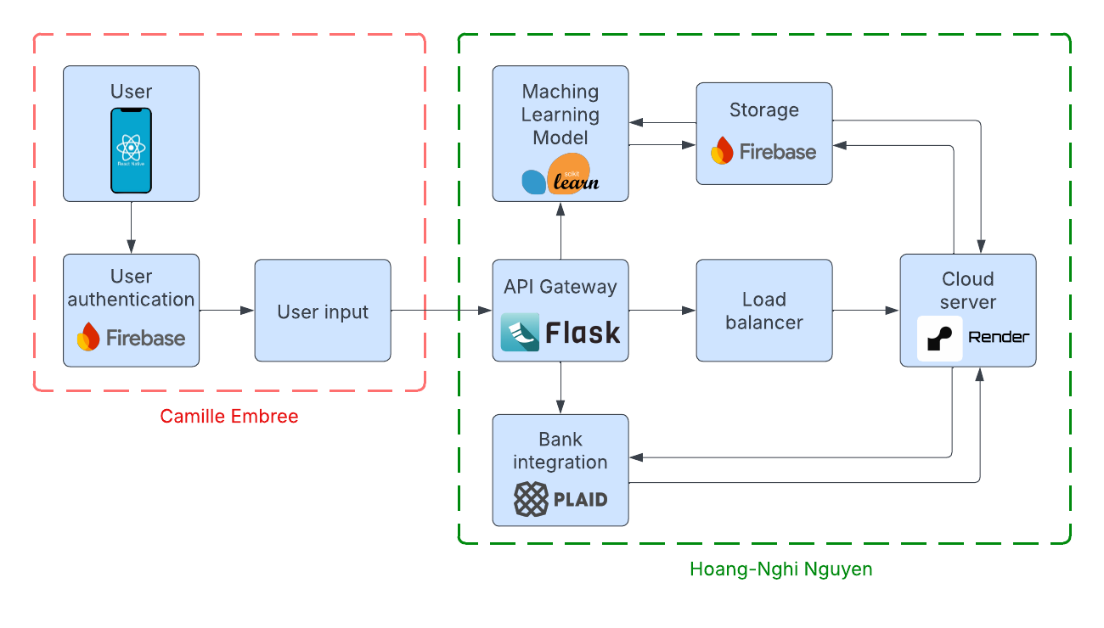

**Figure 1. System Units Block Diagram**

## Modes of Operations

The Personalized Financial Advisor system operates through several distinct modes that reflect the user’s interaction state and the corresponding backend functionalities. These modes ensure secure data handling, stable application behavior, and consistent user experiences across analytics and gamified components. The primary modes of operation are: **Authentication**, **Bank Linking**, **Data Synchronization**, **Analytics**, **Gameplay**, and **Progression**.

### 1. Authentication

This mode governs how users access the system. Upon opening the application, the user authenticates through Firebase Authentication, receiving a valid ID token. All subsequent backend requests require this token, which the backend verifies before authorizing access to user-specific data.

### 2. Bank Linking (Plaid Integration)

In this mode, users connect their financial institution through the Plaid Link interface integrated into the frontend. Once the user successfully completes the guided Plaid flow, the frontend transmits the public token and Firebase ID token to the backend, which exchanges it for a permanent access token and stores associated metadata in Firestore.

### 3. Data Synchronization (Transaction Retrieval & Storage)

Once a Plaid account is linked, the backend enters data synchronization mode on demand or at user-initiated points (e.g., pressing “Refresh Transactions”). The backend retrieves recent transactions through the Plaid Transactions API, normalizes fields, and writes them to Firestore.

### 4. Analytics

This mode is activated whenever the user accesses dashboards, graphs, or category summaries. The backend aggregates stored transaction data into meaningful financial indicators, such as spending by category, timeline trends, and monthly budget utilization. The frontend renders these results visually.

### 5. Gameplay

Gameplay mode includes all interactions with the system’s three minigames: Smart Saver Quiz, Financial Categories, and Spend Detective. In this mode, the backend generates game content, evaluates responses, updates state, and enforces gameplay rules.

**Key Characteristics:**

* **Smart Saver Quiz:** Generates conceptual finance questions; evaluates answers; awards XP.
* **Financial Categories:** Tests user classification of transactions; validates responses; provides explanations.
* **Spend Detective:** Creates transaction mixes with synthetic anomalies; enforces attempts; manages weekly play limits.
* Backend performs scoring, progression updates, and state persistence.
* Firestore stores game history, timestamps, attempts, and outcomes.

### 6. Progression

Progression mode governs the long-term user experience by tracking earned experience points, user levels, and weekly reset conditions. This mode is indirectly triggered whenever the user completes gameplay actions, views their profile, or checks weekly availability.

## Users

The primary users of the Personalized Financial Advisor system are college students seeking accessible tools to monitor their spending, build healthier financial habits, and improve their financial literacy. These users often balance academic responsibilities, limited income, and unpredictable expenses, creating a need for automated financial management tools that minimize manual effort and provide clear, meaningful insights.

### Primary User Group: Student Users

Student users form the core demographic and interact directly with all components of the system. Their operational needs and behaviors define the system’s feature set and user flows. These users typically:

* Hold checking or savings accounts at mainstream financial institutions.
* Desire simple and reliable ways to track expenditures without manually categorizing receipts or entering transaction details.
* Benefit from visualizations that clarify overall spending patterns, categories, and budget progress.
* Engage with gamified learning modules to strengthen budgeting skills, recognize spending anomalies, and learn fundamental financial concepts.

Student users access the system exclusively through the mobile application, authenticate using Firebase, link financial accounts via Plaid, and use the app’s dashboards, analytics, and gameplay modules to improve their financial literacy.

### Secondary User Group: Developers and Maintainers

This group includes project contributors, system maintainers, and academic stakeholders who require access to backend services and system logs but do not participate as typical financial app users. Their responsibilities involve:

* Updating backend logic, especially analytics and game engines.
* Maintaining secure integration with Plaid and Firebase services.
* Monitoring system behavior, debugging errors, and validating new functionality.
* Ensuring compliance with deployment constraints on Google Cloud Run.

These users interact with system infrastructure, source code, and logging tools, but do not use the mobile interface for personal financial management.

## Support

The Personalized Financial Advisor system requires a combination of software services, cloud infrastructure, and third-party integrations to remain operational. Support for the system encompasses ongoing maintenance activities, technical dependencies, and the external services needed to ensure reliable data ingestion, analytics generation, and gameplay functionality.

### Cloud Infrastructure Support

The backend is deployed on **Google Cloud Run**, which provides serverless container execution, automatic scaling, and managed routing. Support activities include:

* Monitoring Cloud Run service logs and error reports.
* Ensuring environment variables (e.g., Plaid credentials, Firebase configuration) remain valid and up to date.
* Updating container images when backend modifications or security patches are made.
* Managing quotas and usage limits to prevent service disruption.

### Firebase Support

The system relies on Firebase for both authentication and data storage. Required support includes:

* Maintaining **Firebase Authentication** configurations and ensuring ID token verification flows continue to function.
* Monitoring **Firestore database usage**, capacity, and structure.
* Managing read/write rules to maintain secure access control.
* Performing data cleanup or restructuring tasks as system features evolve.

### Plaid API Support

Since transaction ingestion is a core function, ongoing support for the Plaid integration is critical. Responsibilities include:

* Managing Plaid client credentials and environment settings.
* Monitoring Plaid API rate limits and responding to API outages or maintenance windows.
* Updating Plaid version dependencies or request formats as required by the SDK.
* Testing transaction retrieval workflows when banks, account types, or Plaid features change.

### Mobile Application Support

The React Native frontend requires maintenance to ensure compatibility with evolving operating system versions, device requirements, and package dependencies. Support tasks include:

* Updating React Native libraries and third-party dependencies.
* Resolving UI or navigation issues related to iOS and Android platform updates.
* Ensuring Plaid Link configuration remains compatible with mobile environments.
* Performing general bug fixes and enhancements to improve the user experience.

### Game Logic and Analytics Support

The minigame system and analytics engine depend on backend logic that must be maintained as user behavior evolves. Support activities include:

* Validating correctness of analytics outputs (e.g., category mappings, spending totals).
* Adjusting game difficulty, scoring parameters, or anomaly generation logic as needed.
* Monitoring XP progression balance to ensure fairness and usability.
* Updating quiz content and categories to keep educational material relevant.

### Security and Compliance Support

Because the system handles sensitive financial data through Plaid and Firebase, ongoing security support is required:

* Regularly reviewing API keys, access tokens, and deployment secrets.
* Ensuring HTTPS enforcement and secure communication across all services.
* Keeping dependencies up to date to address security vulnerabilities.
* Maintaining compliance with Plaid’s data-handling requirements and Firebase security standards.

# 

# Scenario(s)

## First-Time User Sign-In and Account Setup

**Objective:** A new user opens the application, signs in, and prepares the system for financial tracking.

**Steps:**

1. The user opens the mobile application and selects a sign-in method.
2. Firebase Authentication generates a secure ID token for the session.
3. The app stores the token and uses it for all subsequent backend requests.
4. The user navigates to the “Connect Bank” screen to link a financial account.
5. The frontend launches the Plaid Link interface, and the user completes the bank-connection process.
6. The frontend sends the returned Plaid public token to the backend along with the Firebase ID token.
7. The backend exchanges the public token for a long-lived access token and stores it securely in Firestore.
8. The app confirms that financial account linking is complete and transitions the user to the home dashboard.

**Outcome:** A verified user profile is created, banking access is established, and the system is ready to retrieve transactions and generate analytics.

## Transaction Synchronization and Dashboard Viewing

**Objective:** A user checks their budget, spending categories, and recent activity.

**Steps:**

1. The user opens the app and Firebase automatically refreshes their ID token.
2. The user navigates to the main dashboard or analytics tab.
3. The frontend requests updated analytics from the backend.
4. The backend verifies the ID token and retrieves normalized transactions from Firestore.
5. If synchronization is required, the backend queries Plaid for new transactions and updates Firestore.
6. The backend computes:
   * Spending by category
   * Total spending vs. monthly budget
   * Recent transaction summaries
   * Trendlines for spending over time
7. The analytics data is returned to the frontend in structured JSON format.
8. The frontend renders graphs, pie charts, and budget indicators accordingly.

**Outcome:**The user receives real-time financial insights derived directly from their linked account activity.

## Playing Smart Saver Quiz

**Objective:** The user participates in the financial literacy quiz to gain XP.

**Steps:**

1. The user selects “Smart Saver Quiz” from the games menu.
2. The frontend requests a quiz question from the backend.
3. The backend retrieves a pre-defined question, returns answer choices, and records the session state.
4. The user selects an answer.
5. The frontend sends the answer to the backend for validation.
6. The backend evaluates correctness, updates XP and level progression, and returns a result message with explanation.
7. The frontend displays feedback and allows the user to proceed to the next question.

**Outcome:** The user strengthens conceptual knowledge and progresses toward higher levels in the app.

## Playing Financial Categories

**Objective:** The user learns to categorize transactions and understand spending behavior.

**Steps:**

1. The user selects Financial Categories from the games menu.
2. The frontend requests a set of transactions for categorization.
3. The backend selects representative transactions from Firestore and returns them with category prompts.
4. The user assigns categories to each item.
5. The backend validates answers, awards XP, updates the user’s level, and provides corrective explanations.
6. The frontend displays results and progression changes.

**Outcome:**The user practices skill-building with genuine spending data, reinforcing categorization accuracy.

## Playing Spend Detective

**Objective:** The user identifies fake transactions inserted into their real transaction list.

**Steps:**

1. The user navigates to Spend Detective.
2. The frontend requests a new game session.
3. The backend checks whether the user is eligible (weekly cooldown).
4. If eligible, the backend:
   * Retrieves recent transactions from Firestore (past week)
   * Generates several synthetic anomalies
   * Mixes them into a unified list
   * Initializes attempts counter and anomaly count
5. The frontend displays the mixed transaction set.
6. The user selects items they believe are anomalies.
7. For each guess, the backend:
   * Validates correctness
   * Updates attempt count
   * Updates found-anomaly count
   * Determines win/loss conditions
8. When the game ends, the backend records completion time, updates XP/level, and sets weekly lockout.
9. The frontend presents the end-game screen and progression rewards.

**Outcome:** The user engages with anomaly detection in a realistic financial context, improving their attention to unusual spending behavior while earning progression rewards.

## Viewing Progression and Profile

**Objective:** The user checks their XP, level, and weekly cooldowns.

**Steps:**

1. The user navigates to the profile or progression screen.
2. The frontend requests progression data from the backend.
3. The backend retrieves:
   * Total XP
   * Current level
   * XP thresholds
   * Last game completion times
   * Weekly lockout status for Spend Detective
4. The backend returns this information to the frontend.
5. The frontend visualizes levels, XP bars, and lockout timers.

**Outcome:** The user understands their standing within the app’s gamified system and is motivated to continue interacting with the platform.

## Error Handling and Constraint Conditions

**Objective:** The user attempts actions when constraints prevent normal operation.

**Examples of constraints:**

* No Plaid account linked.
* Insufficient recent transactions for Spend Detective.
* Authentication token expired.
* Plaid API outage.
* Backend connectivity issues.

**System Behavior:**

1. The user attempts an action the system cannot perform.
2. The backend rejects the request with an actionable error message.
3. The frontend displays a clear, user-friendly explanation and next steps.
4. The system prevents unauthorized or incomplete operations until the constraint is resolved.

**Outcome:** Operations remain safe, consistent, and predictable even under error conditions.

# 

# Analysis

## Summary of Proposed Improvements

During the final development cycle, the system underwent a significant architectural refinement that resulted in a more scalable, automated, and user-aligned solution. The most substantial improvement was the transition from a receipt-based OCR workflow to a Plaid-driven transaction ingestion pipeline, eliminating the need for manual image uploads or inconsistent text extraction. This shift greatly improved accuracy, reduced user burden, and enabled real-time access to verified financial data.

In parallel, the analytics layer was redesigned to compute spending summaries, category distributions, and budgeting trajectories directly from normalized Firestore transaction records. These improvements created a more consistent and intuitive user experience across the dashboard and analysis views.

Another major enhancement was the introduction of an integrated gamified learning environment, composed of Smart Saver Quiz, Financial Categories, and Spend Detective. These modules leverage real transaction data and structured financial-literacy concepts to deliver interactive, educational experiences. A progression system, tracking experience points, levels, and cooldowns, was added to reinforce engagement and create meaningful feedback loops.

## Disadvantages and Limitations

Although the revised architecture provides substantial benefits, several limitations remain inherent to the system:

### Dependence on Third-Party APIs

The system relies heavily on Plaid for transaction retrieval. Any Plaid outage, API rate limitation, or environment misconfiguration can disrupt critical functionality. In addition, Plaid’s update intervals mean that the system does not always reflect real-time financial activity.

### Data Availability Constraints

Users with limited or infrequent transactions may encounter reduced functionality in components such as Spend Detective. To address this, synthetic anomalies are injected, but gameplay quality still depends on the presence of meaningful transaction history.

### Mobile Platform Constraints

React Native introduces variability across Android and iOS devices, requiring continuous dependency management and testing. Changes in mobile OS behavior may require periodic app maintenance to maintain compatibility.

### Security and Compliance Requirements

While Plaid mitigates the handling of sensitive banking credentials, the system still must enforce strict authentication, encryption, and data-storage rules. Misconfigurations in Firebase rules or Cloud Run environment variables could compromise security or availability.

### Limited Personalization Scope

Current financial insights are rule-based and derived directly from transaction patterns. The system does not yet incorporate machine-learning-driven personalized advice, risk assessment, or predictive budgeting, which may limit long-term adaptability.

## Alternatives

Several alternative approaches were evaluated during development:

### Receipt-Based OCR Pipeline (Initial Design)

The original concept relied on scanning receipt images, extracting text with OCR, and classifying spending categories using an ensemble ML model. While this approach allowed granular tracking, it imposed substantial user burden, suffered quality variability, and provided inconsistent data. The Plaid approach proved far more reliable and automated.

### GPT-Based Financial Feedback

Early versions included GPT-generated personalized financial advice. Although capable of producing rich narrative explanations, this solution was more expensive, dependent on external APIs, and difficult to validate for consistency and correctness. Gamified modules were selected as a more controlled and educational alternative.

### Rule-Based Budget Alerts Only

A simpler pathway would have used analytics alone without gamification. However, analysis showed that students benefit more from active learning than passive dashboards. The final system includes both analytics and games to support diverse user learning styles.

### Local Device Storage Instead of Firestore

Storing transaction data locally was considered for performance and offline access. However, this approach introduced security risks, limited cross-device consistency, and complicated backend logic. Firestore offered secure, scalable, cloud-based storage with less maintenance overhead.

## Impact

The architectural and functional improvements introduced in the final system have several key impacts:

### Improved Usability and User Experience

Transitioning to Plaid eliminated manual data entry, enabling effortless onboarding and continuous financial tracking. This dramatically improved user satisfaction and reduced friction compared to receipt scanning.

### Higher System Reliability and Scalability

By leveraging Google Cloud Run and Firebase, the backend now scales automatically with user demand, reduces operational overhead, and maintains efficient performance across analytics, games, and progression features.

### Enhanced Educational Value through Gamification

The introduction of interactive financial-literacy games transforms the application from a passive budgeting tool into an active learning platform. Students gain practical skills through repetition, reinforcement, and engagement rather than static advice.

### Secure and Compliant Data Handling

The revised design maintains strict boundaries around sensitive information through token-based authentication, secure Plaid integration, and Firestore access rules, reducing compliance risks and improving system trustworthiness.

### Foundation for Future Expansion

The modular architecture: Plaid transaction pipeline, analytics engine, game subsystem, and progression framework, provides a robust foundation for future enhancements such as predictive budgeting, spending recommendations, or additional gamified modules.

Financial Advisor App for Students

Camille Embree, Hoang-Nghi Nguyen

**Functional System Requirements**

REVISION – 2

6 December 2025

Functional System Requirements

for

Financial Advisor App for Students

Prepared by:

_____________________________

Author Date

Approved by:

_____________________________

Project Leader Date

_____________________________

John Lusher, P.E. Date

_____________________________

T/A Date

**Change Record**

| **Rev.** | **Date** | **Originator** | **Approvals** | **Description** |
| --- | --- | --- | --- | --- |
| **1** | 2/20/2025 | Financial Advisor App for Students |  | Draft Release |
| **2** | 12/7/2025 | Hoang-Nghi Nguyen |  | Revision to all concepts to reflect fundamental changes in the core of the project |

**Table of Contents**

**List of Figure****s** **31**

**1. Introduction** **32**

1.1. Purpose and Scope 32

1.2. Responsibility and Change Authority 32

**2. Requirements** **33**

2.1. System Definition 33

2.2. Characteristics 34

2.2.1. Functional / Performance Requirements 34

2.2.2. User Interface and Experience 36

2.2.3. Data Handling and Security 37

2.2.4. System Scalability and Integration 38

2.2.5. Error Handling and Fault Tolerance 39

**3. Support Requirements** **40**

**Appendix A: Acronyms and Abbreviations** **41**

**Appendix B: Definition of Terms** **42**

**List of Figures**

[**Figure 1.** Block Diagram of System](https://docs.google.com/document/d/1HI3k-dRsa3aTesSoNpU5QRLBi3-OpZflQ-VpZdAasgM/edit#heading=h.1t3h5sf)33

# 

# Introduction

## Purpose and Scope

The purpose of this Functional System Requirements (FSR) document is to define the functionality, operational constraints, performance expectations, and behavioral requirements of the Personalized Financial Advisor application. The FSR describes what the system must accomplish to support its primary objective: providing college students with automated financial tracking, data-driven spending insights, and gamified financial literacy training.

The scope of the system includes all functions necessary to ingest financial data from Plaid, store and manage that data in Firebase Firestore, compute relevant spending analytics, deliver interactive minigames, and track user progression. These requirements apply to the mobile frontend, backend services deployed on Google Cloud Run, database components, and all external integrations. This document captures the functional expectations of both the analytic and gamified components, ensuring that system behavior is well-defined, consistent, and verifiable throughout development and deployment.

## Responsibility and Change Authority

Responsibility for implementing, validating, and maintaining the requirements outlined in this document is shared among the project development team composed of the backend developer(s), frontend/mobile application developer(s), and system integrator(s). Each team member is responsible for ensuring that their subsystem satisfies all functional requirements and interfaces correctly with the remainder of the system.

Changes to the requirements defined in this document will follow a structured change-control process. Any modification, addition, or removal of requirements must be reviewed and approved by the team as a whole. This includes evaluating the technical feasibility, user impact, and integration complexities associated with each proposed change. Final authority for approving requirement modifications rests jointly with the project lead(s) and faculty advisor overseeing the capstone project. All approved changes must be documented and version-controlled to maintain traceability across the project's lifecycle.

# Requirements

## System Definition

The Personalized Financial Advisor system is a mobile-focused financial management and learning platform that automatically retrieves a user's bank transactions through Plaid, stores and processes these transactions in Firebase Firestore, and provides financial insights through dashboards and gamified learning modules. The system must authenticate users securely, maintain accurate financial data, generate real-time analytics, and support game logic including scoring, anomaly detection, quiz behavior, and progression tracking.

The requirements below define the expected functional behavior of the system, ensuring consistency, reliability, and secure handling of financial information across the mobile app, backend service, and cloud-hosted data environment.



**Figure 1. Block Diagram of System**

The front-end of this project will primarily focus on building a user-friendly interface for students to easily view their current budget progress, an analysis of their spending, and resources to build financial literacy. It shall be straightforward and comprehensible as well as engaging so that students don’t forget to check it and utilize all of the functions available.

## 

## Characteristics

### Functional / Performance Requirements

#### **API Response Time Test**

The system shall maintain efficient backend performance, with API response times ≤ 500 ms under normal network conditions for standard operations such as analytics retrieval, game logic requests, and transaction lookups.

*Rationale: Fast response times ensure smooth interaction across the mobile application. Delays in analytics loading or game submissions degrade usability and discourage user engagement. A 500 ms threshold aligns with mobile UI performance expectations and prevents user frustration.*

#### **Bank Transaction Fetching (Plaid Integration)**

The system shall reliably retrieve and update bank transactions for authenticated users through the Plaid API. Both valid and invalid credential cases shall be supported for error-handling tests.

*Rationale: Users rely on timely access to accurate financial data. Missing, outdated, or incorrectly fetched transactions lead to inconsistent analytics and impaired budgeting decisions. Reliable transaction ingestion ensures alignment between user expectations, Firestore data, and bank records.*

#### **Database Read/Write Performance**

The system shall complete ≥ 90% of Firestore read and write operations within ≤ 200 ms, including fetching transactions, storing gameplay state, and updating user progression.

*Rationale: The application relies on real-time synchronization between frontend and backend. Slow database interactions can cause stale analytics, incorrect game states, or interface lag. A 200 ms target ensures responsive updates consistent with real-time mobile applications.*

#### **End-to-End Module Functionality**

Each module: authentication, Plaid integration, analytics engine, minigames, and progression, shall function correctly in isolation and when integrated. Combined system tests must confirm consistent data flow, error handling, and UI updates.

*Rationale: A failure in any subsystem (authentication, analytics, game logic) can render the entire app unusable. Testing modules in isolation prevents cascading failures, while integrated tests verify smooth cross-component operation.*

#### **Transaction Categorization & Display**

The backend shall correctly normalize, categorize, and structure all transactions retrieved from the Plaid API before storing them in Firebase Firestore. Each transaction must include accurate fields for amount, date, merchant name, Plaid category, and the system’s internal high-level category mapping. When requested by the frontend, the backend shall return these transactions in a consistent JSON format that supports accurate display in the UI, analytics charts, and all minigames.

*Rationale: Accurate normalization and categorization are essential for ensuring that financial insights, spending summaries, and game content reflect the user’s true financial activity. Incorrect categorization or field mapping can lead to misleading budget calculations, faulty analytics, and inconsistencies across games such as Financial Categories and Spend Detective. Ensuring backend consistency prevents errors in the UI and maintains user trust in the system’s financial accuracy.*

#### **Expense Tracking & Budgeting**

The backend shall accurately compute and return up-to-date expense totals and budget utilization metrics based on the user’s stored transaction data. This includes aggregating spending across all relevant transactions for a defined budgeting period, grouping totals by category when requested, and comparing total expenditures against the user’s configured budget amount. All calculations shall be performed using normalized transaction data stored in Firestore to ensure consistency across app sessions and analytics features.

*Rationale: Accurate expense tracking is critical for enabling users to understand their financial position and make informed budgeting decisions. If aggregated totals or budget comparisons are incorrect, users may overestimate or underestimate their available funds, reducing trust in the system and diminishing the value of the budgeting feature. Performing these calculations on normalized backend data ensures consistency between dashboards, analytics screens, and game modules that rely on spending summaries.*

#### **Minigame Functionality**

The backend shall reliably support all core gameplay operations for Smart Saver Quiz, Financial Categories, and Spend Detective. For each minigame, the backend shall:

1. Generate or retrieve appropriate game content (e.g., questions, transactions, anomalies).
2. Validate user responses according to game-specific rules.
3. Maintain accurate game state, including attempts, session outcomes, timestamps, and weekly cooldowns.
4. Update the user’s experience points (XP) and level progression in Firestore.
5. Return structured JSON responses to the frontend that clearly indicate correctness, updated game state, and rewards earned.

The backend must ensure stable operation with no crashes, scoring inconsistencies, or invalid state transitions during gameplay.

*Rationale: The minigames represent a major component of the system’s educational and engagement value. Because game logic is executed on the backend, reliability is essential to prevent incorrect scoring, inconsistent progression updates, and game flow interruptions that would diminish user trust and motivation. Ensuring consistent backend state management also maintains fairness across sessions and supports accurate weekly lockout enforcement for Spend Detective.*

### User Interface and Experience

#### **Home Tab**

The Home Tab shall present a clear and concise overview of the user’s financial status, including recent spending highlights, budget progress, and navigation options to analytics and games. The layout shall allow new users to understand the essential information and available actions within four minutes of first-time use.

*Rationale: The Home Tab is the primary entry point of the application and must communicate key financial insights without overwhelming the user. A simple and intuitive layout improves user engagement, reduces cognitive load, and supports accessibility for students with varying levels of financial literacy.*

#### **Tracking/Analysis Tab**

The Tracking/Analysis Tab shall display accurate and dynamically updated graphs, charts, and summaries that reflect the user’s recent spending behavior. Data must update automatically when new transactions are retrieved and must render correctly across supported mobile devices.

*Rationale: Visual analytics help users interpret spending patterns more effectively than raw numbers. Accurate, up-to-date graphs are essential for enabling users to identify trends, categorize expenses, and make informed budgeting decisions.*

#### **MIni-games Tab**

The Minigames Tab shall provide an intuitive, visually engaging navigation interface that allows users to access Smart Saver Quiz, Financial Categories, and Spend Detective within four or fewer interactions. The tab shall correctly display game availability (e.g., weekly lockouts for Spend Detective) and update dynamically based on backend data.

*Rationale: Easy access to the minigames promotes user engagement and encourages regular participation in financial learning activities. A consistent and responsive UI ensures that game availability is clearly communicated and prevents user confusion or misnavigation.*

#### **Account Page**

The Account Page shall display validated and authenticated user information, including email, linked bank status, progression level, and log-out controls. The page shall only show data retrieved for the authenticated user and shall not display or expose any sensitive financial details.

*Rationale: The Account Page is critical for user trust and identity management. Ensuring that it displays only verified information prevents accidental data leaks and reinforces security expectations for users accessing personal financial content.*

#### **Sounds**

The application shall produce appropriate sound effects in response to user interactions such as button presses, game results, and navigation cues. Audio feedback must trigger within ≤0.1 seconds after the associated user action and must not play erroneously or multiple times for a single event.

*Rationale: Auditory feedback enhances user engagement and improves the intuitiveness of interactive interfaces. Consistent, correctly timed sound effects help users perceive responsiveness and reinforce correct navigation or game outcomes.*

#### **Animations**

All animations, including loading indicators, page transitions, and game state updates, shall render smoothly within ≤0.2 seconds of their triggering event. Animations must complete without stutter, flicker, or misalignment across supported device types.

*Rationale: Smooth animations enhance perceived performance and professionalism. Poorly rendered animations can create confusion, reduce user satisfaction, and imply application instability even when functionality is correct.*

#### **Database Integration**

The system shall reliably read from and write to Firebase Firestore for all user-related operations, including transaction storage, game state updates, XP and level progression, and Plaid metadata. All database operations must complete without corruption, duplication, or data loss, and must maintain consistency across sessions and devices.

*Rationale: Firestore acts as the authoritative data source for the entire application. Reliable database integration ensures that analytics, game logic, and user progression remain accurate and consistent. Failures in database operations would compromise financial insights, gameplay continuity, and overall trust in the system.*

### Data Handling and Security

#### **Secure Transaction Storage**

All financial transaction data must be securely stored in Firebase Firestore with encryption enabled. Testing will verify that transactions are stored correctly and cannot be accessed without proper authentication.

*Rationale: Financial transactions contain sensitive personal information. Encryption ensures data security and compliance with best practices for financial applications.*

#### **Authentication and Access Control**

User accounts must be protected with secure authentication mechanisms, including password encryption and Firebase Authentication. Tests will include login attempts with incorrect passwords and unauthorized access attempts.

*Rationale: Protecting user accounts from unauthorized access is essential. Firebase Authentication provides a secure, industry-standard mechanism for login and account recovery.*

#### **Data Integrity and Validation**

The system must prevent invalid or incomplete data entries. All user inputs should be tested against predefined integrity rules to ensure correctness. Invalid transactions should be rejected to maintain accurate financial tracking.

*Rationale: Incorrect or corrupted data compromises accuracy. Validation ensures data reliability, preventing duplicate or inconsistent records.*

#### **API Security and Error Handling**

Flask API endpoints must handle errors properly, including invalid transaction data and unauthorized access attempts. Testing will include sending incorrect API requests and verifying proper error messages are returned instead of system crashes.

*Rationale: Proper error handling is critical for security and usability. Without it, invalid inputs or unauthorized access attempts could cause system crashes or expose sensitive information. Clear and structured error messages help users understand issues while preventing attackers from exploiting vulnerabilities. Implementing proper error handling ensures system stability, security, and a better user experience.*

### System Scalability and Integration

#### **Backend API Performance**

The Flask backend must handle increasing numbers of concurrent users and API requests without performance degradation. Load testing will simulate multiple concurrent requests to ensure the system remains responsive.

*Rationale: As more users join the platform, the backend must scale efficiently. Ensuring API performance prevents slowdowns or crashes due to high traffic.*

#### **Frontend-Backend API Integration**

The React Native frontend must communicate smoothly with the Flask backend. API responses should be properly formatted and displayed in the UI without breaking the application. Testing will include sending incorrect API data and observing error handling.

*Rationale: Seamless frontend-backend communication ensures that users always see updated and consistent data. Improper integration could cause UI glitches or incorrect financial insights.*

#### **Handling Edge Cases**

The system should be resilient against unusual inputs, such as empty transaction histories, duplicate entries, or corrupted data. Edge case testing will verify that such conditions do not cause crashes or incorrect calculations.

*Rationale: Handling edge cases prevents system crashes and ensures accurate calculations. It ensures the app remains stable and reliable, even with unexpected inputs, enhancing user trust and experience.*

#### **Future Scalability Considerations**

The system must be designed to integrate additional financial data sources and expand machine learning capabilities without requiring major architectural changes.

*Rationale: Building for scalability ensures the system can grow and adapt to future requirements without significant changes. This flexibility supports long-term sustainability and allows for the addition of new features, improving the app’s value and performance over time.*

### Error Handling and Fault Tolerance

#### **Transaction Categorization Accuracy**

Transactions retrieved from Plaid must be correctly categorized and stored. Sample transaction data will be used to verify whether categories like "Food" and "Rent" match expected classifications.

*Rationale: Poor categorization can lead to misleading financial reports. Ensuring correct classification reduces user corrections and improves budgeting insights.*

#### **Expense Tracking Consistency**

The expense tracking feature must maintain long-term consistency in financial calculations. Simulated expense entries will be tested over extended periods to validate tracking accuracy.

*Rationale: Users rely on expense tracking for long-term budgeting. If calculations become inconsistent, financial predictions and budgets will be inaccurate, leading to poor decision-making.*

#### **API Failure Handling**

The backend must handle API failures gracefully, providing appropriate error messages rather than crashing. Tests will simulate scenarios such as Plaid being temporarily unavailable.

*Rationale: Third-party API failures are unavoidable, but system crashes can be prevented. Proper error handling ensures users are informed of issues rather than experiencing app failures.*

#### **User Error Recovery**

Users must be able to recover from input errors without data loss. Testing will involve incorrect inputs in forms and ensuring users can correct mistakes easily.

*Rationale: Mistakes in financial apps are common. Allowing users to correct errors prevents frustration and ensures data accuracy.*

#### **Alert System Reliability**

Push notifications must deliver accurate and timely alerts regarding spending limits and budget warnings. A test environment will track whether alerts are successfully received on mobile devices.

*Rationale: Ensuring reliable alerts is essential for user engagement and financial management. Timely, accurate notifications help users stay on top of their spending, while proper testing guarantees that the system delivers critical alerts without failure. This enhances user experience and helps maintain the app’s reliability.*

# Support Requirements

In order to display our app system as expected, users will require a mobile device of IOS version 13.4 or above. They may also use an Android device of version 6 or above, however the layout likely won’t be as functional and IOS is recommended.

The financial tracking app will require a comprehensive support system to ensure smooth operation, user satisfaction, and long-term success.

1. **User Support**: Users should have access to clear documentation, FAQs, and self-help resources, as well as responsive support through live chat or email for resolving issues such as login problems, transaction disputes, or feature inquiries.
2. **Technical Support**: The backend and infrastructure should be regularly monitored for potential issues, such as server downtime, database errors, or API failures. Timely bug fixes and system updates will be essential for maintaining reliability.
3. **Security and Data Integrity**: Continuous monitoring and prompt patching of security vulnerabilities, including data breaches, authentication issues, and encryption, will be crucial. Regular audits and compliance checks will also ensure the protection of sensitive user data.
4. **Scalability Support**: As the app grows, support will be required for scaling both the infrastructure and feature set. This includes optimizing server performance, expanding data storage capabilities, and managing additional financial data sources or machine learning models.

# Appendix A: Acronyms and Abbreviations

API Application Programming Interface

DB Database

GCP Google Cloud Platform

GCR Google Cloud Run

JSON JavaScript Object Notation

ML Machine Learning

NoSQL Not Only SQL

REST Representational State Transfer

SDK Software Development Kit

UI User Interface

UX User Experience

ICD Interface Control Document

# Appendix B: Definition of Terms

**API (Application Programming Interface)**: A set of protocols, tools, and definitions that allow different software applications to communicate with each other. In the context of the app, the API facilitates data exchange between the frontend (React Native) and backend (Flask).

**DB (Database)**: A system used to store, manage, and retrieve data. In this project, Firebase Firestore is used as the NoSQL database to store user information, transaction records, and other financial data.

**GCP (Google Cloud Platform):** A suite of cloud services used to deploy and manage the application’s backend infrastructure. In this project, GCP provides hosting for Cloud Run and integrates with Firebase for authentication and data storage.

**GCR (Google Cloud Run):** A serverless compute platform on GCP that runs the backend as a containerized service. In this project, Cloud Run executes Flask API requests, scales automatically, and connects to Firebase and Plaid.

**JSON (JavaScript Object Notation)**: A lightweight, text-based data format used for exchanging data between the client (frontend) and server (backend). JSON is easy for both humans and machines to read and write.

**ML (Machine Learning)**: A subset of artificial intelligence that involves the use of algorithms and statistical models to analyze data, learn from it, and make predictions. In this project, ML is used for extracting financial data from receipts and providing personalized financial advice.

**NoSQL (Not Only SQL)**: A type of database designed to handle unstructured or semi-structured data. Firestore, a NoSQL database, is used in this project to store dynamic, scalable user and financial data.

**REST (Representational State Transfer)**: An architectural style for designing networked applications. RESTful APIs use standard HTTP methods (GET, POST, PUT, DELETE) to manage data and ensure stateless interactions between the client and server.

**SDK (Software Development Kit)**: A collection of tools, libraries, and documentation that help developers build applications. For this project, SDKs from third-party services like Plaid are used to integrate bank transaction data into the app.

**UI (User Interface)**: The visual part of the application that users interact with, including elements like buttons, forms, and navigation menus. A well-designed UI ensures a smooth user experience.

**UX (User Experience)**: The overall experience of a user when interacting with an application, focusing on ease of use, satisfaction, and efficiency. A strong UX design ensures that users can easily navigate and engage with the app.

Financial Advisor App for Students

Camille Embree, Hoang-Nghi Nguyen

**Interface Control Document**

REVISION – Draft

20 February 2025

Interface Control Document

for

Financial Advisor App for Students

Prepared by:

_____________________________

Author Date

Approved by:

_____________________________

Project Leader Date

_____________________________

John Lusher II, P.E. Date

_____________________________

T/A Date

**Change Record**

| **Rev.** | **Date** | **Originator** | **Approvals** | **Description** |
| --- | --- | --- | --- | --- |
| **1** | 2/2/2025 | Financial Advisor App for Students |  | Draft Release |
| **2** | 12/6/2025 | Camille Embree |  | Final Revisions |

**Table of Contents**

**1. Overview 47**

**2. References and Definitions 47**

2.1. References 47

2.2. Definitions 47

**3. Frontend Interface 48**

3.1. Mobile Operating Systems 48

3.2. React Native Libraries 48

**4. Backend Interface 49**

4.1. Scope 49

4.2. API Communication Protocols 49

4.3. Authentication and Authorization 49

4.4. Third-Party Integrations 49

4.5. Data Management and Storage 49

4.6. Error Handling and Responses 49

4.7. API Rate Limiting 49

**5. Gameplay Interface 50**

5.1. Minigame Engine Integration 50

5.2. Data Flow 50

5.3. Progression and Feedback 50

5.4. Validation and State Recording 50

# Overview

The Interface Control Document defines the interactions and communication between the Frontend (React Native) and the Backend (Flask API) of the Personalized Financial Advisor App for Students. This document outlines the communication protocols, system interfaces, and the operational constraints that will ensure that all components of the financial tracking app (frontend, backend, and machine learning) work seamlessly together, providing users with an intuitive and secure experience while managing their finances.

# References and Definitions

## References

Refer to section 2.3 of the Concept of Operations document.

## Definitions

API Application Programming Interface

DB Database

JSON JavaScript Object Notation

ML Machine Learning

NoSQL Not Only SQL

REST Representational State Transfer

SDK Software Development Kit

UI User Interface

UX User Experience

ICD Interface Control Document

# Frontend Interface

## Mobile Operating Systems

This mobile application was built for IOS of versions 13.4 and above. Android users of version 6 and above are also able to download and use the app, however functionality will be limited.

## React Native Libraries

In order to write code for the front-end of this project, numerous React Native libraries were necessary. Some examples of these main libraries include expo-router for navigation, firebase/auth for authentication, and Plaid Link SDK for bank account linking.

# Backend Interface

## Scope

The backend is responsible for processing API requests from the frontend, storing data, authenticating users, exchanging the secure Plaid token, providing XP/level updates, generating game logic, and performing financial calculations.

## API Communication Protocols

The Flask API will use RESTful APIs for communication with the frontend. Data will be transmitted in JSON format, ensuring efficient and structured data exchange. Endpoints will respond with standardized success flags and actionable error messages.

## Authentication and Authorization

The backend uses a retrieved Firebase ID token for verification. It then validates this token with Google’s public keys. Only authenticated users will be able to access their financial data, ensuring security and privacy.

## Third-Party Integrations

The backend will integrate with external services such as Plaid to retrieve transaction data. It will go about this by first receiving a public_token from the frontend, then exchanging this for an access_token encrypted in Firestore. Calling the Plaid API, transaction data will be pulled, categorized, and stored in the Firestore The backend will also be responsible for managing interactions with the machine learning models.

## Data Management and Storage

The backend will interface with Firebase Firestore, storing transaction records, game information, analytics, and minigame progression. Data will be encrypted and secured to protect user privacy.

## Error Handling and Responses

The backend will return appropriate HTTP status codes (e.g., 400 for bad requests, 401 for unauthorized access) and structured error messages to help the frontend handle issues gracefully.

## API Rate Limiting

External integrations (such as Plaid) will impose rate limits on API requests. The backend will implement mechanisms to handle rate limiting, including queueing requests or notifying users of delays.

# Gameplay Interface

## Minigame Engine Integration

The backend will generate and validate content for each of the three minigames; smart saver quiz, financial categories, and spend detective. The game has individual API endpoints that allow a user to generate content, retrieve question sets, submit answers, and receive results/XP updates.

## Data Flow

To begin game generation the frontend will send a request to the backend, where user eligibility will be verified. The backend will return game content at which point the user’s responses will be returned. Finally, the backend will evaluate answers and update XP progression accordingly, which will be sent to and displayed by the frontend.

* 1. ***Progression and Feedback***

The backend subsystem will calculate XP per correct answer, level thresholds, remaining attempts, and weekly lockout timers.

* 1. ***Validation and State Recording***

The backend will record the state of game history, timestamps, XP earned, and cooldown states.

Financial Advisor App for Students

Camille Embree, Hoang-Nghi Nguyen

**Schedule and Validation**

**Table of Contents**

**1. Execution Plan 45**

**2. Validation Plan 46**

**List of Tables**

[**Table 1.** Execution Plan Timeline **45**](https://docs.google.com/document/d/1HI3k-dRsa3aTesSoNpU5QRLBi3-OpZflQ-VpZdAasgM/edit#heading=h.1t3h5sf)

[**Table 2.** Validation Plan **46**](https://docs.google.com/document/d/1HI3k-dRsa3aTesSoNpU5QRLBi3-OpZflQ-VpZdAasgM/edit#heading=h.1t3h5sf)

# 

1. **Execution Plan**

The execution plan for the personalized financial advisor app for students can be found below in ***Table 1***. The table was built by considering the amount of hours that would be dedicated to each task, and planning out those assignments chronologically based on these estimates. While we did fall behind during weeks 3/23-3/30, we were able to quickly readjust and complete all of our tasks for the first semester.

*Table 1. Execution Plan Timeline*

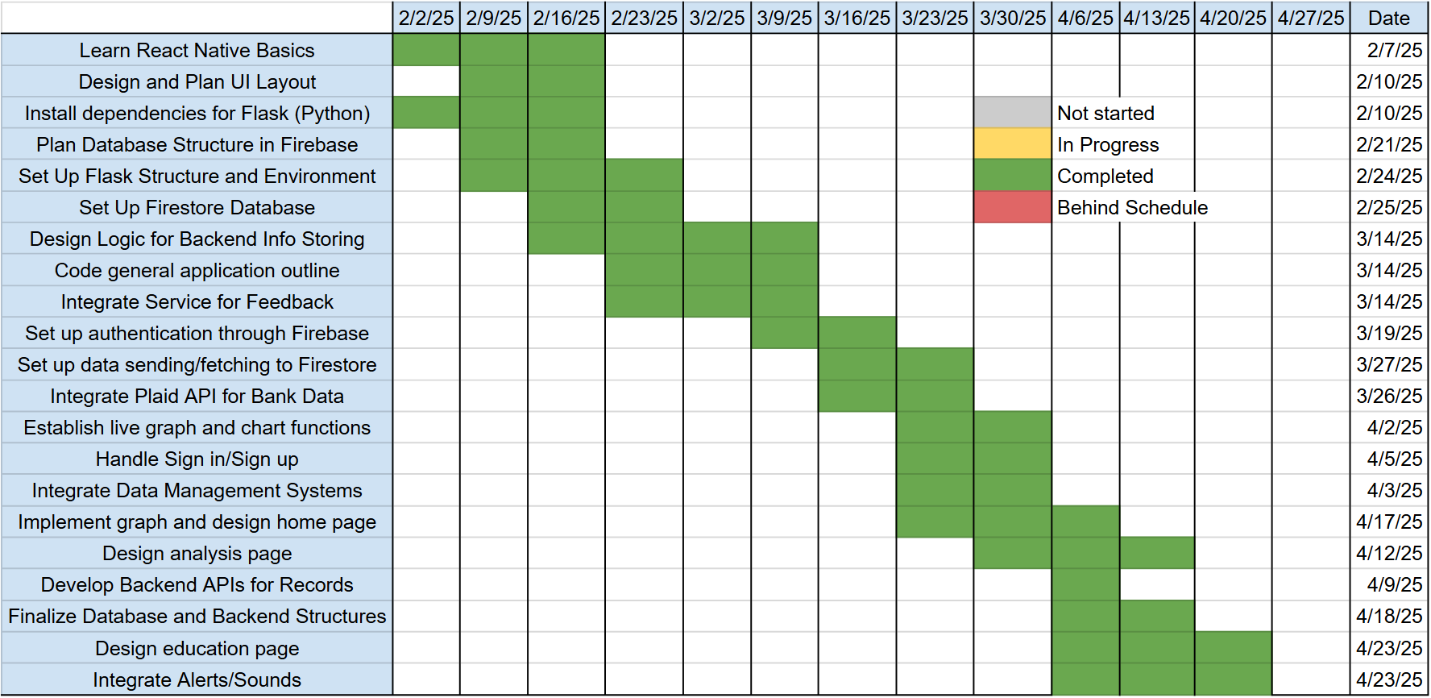

1. **Validation plan**

The validation plan for our application can be found below in ***Table 2***. The blue represents backend structures, and the orange displays frontend operations. Each test can be associated with the respective paragraph in the Functional System Requirements section found above. There, you can find more detailed information about the purpose and validity of each test.

*Table 2. Validation Plan*

| Paragraph # | Test Name | Success Criteria | Methodology | Status | Responsible Engineer(s) |
| --- | --- | --- | --- | --- | --- |
| 2.2.1.1 | API Response Time Test | API response time should be ≤ 500ms under normal load. | Use Postman or to send multiple requests to Flask endpoints. Identify bottlenecks using Flask debugging and profiling tools. | DONE | Hoang-Nghi Nguyen |
| 2.2.1.2 | Bank Transaction Fetching | The system successfully fetches and updates bank transactions for sandbox simulation tests. | Simulate API calls to Plaid with valid and invalid credentials. Monitor response times and error handling when Plaid's service is down. | DONE | Hoang-Nghi Nguyen |
| 2.2.1.3 | ML Model Accuracy | The ML model provides at least 85% accuracy in classifying transactions | Feed test datasets with labeled transactions and compare output classifications. | DONE | Hoang-Nghi Nguyen |
| 2.2.1.4 | Database Read/Write Performance | Read/write operations complete in ≤ 200ms for 90% of requests. | Simulate concurrent database queries (fetch transactions, store new data). | DONE | Hoang-Nghi Nguyen |
| 2.2.1.5 | End-to-End Module Functionality | Each core app function works correctly, including authentication, data fetching, ML analysis, and storage. | Test individual modules in isolation (e.g., authentication, API calls, ML predictions). | DONE | Hoang-Nghi Nguyen |
| 2.2.1.6 | Transaction Categorization & Display | Transactions retrieved from Plaid are correctly categorized, stored, and displayed in the app. | Fetch sample transactions and check if categories (e.g., "Food", "Rent") match expected results. Validate ML model outputs for accuracy and consistency. Check if categorized data is stored properly in Firebase Firestore. | DONE | Hoang-Nghi Nguyen |
| 2.2.1.7 | Expense Tracking & Budgeting | The app correctly tracks user expenses and provides budgeting insights without errors. | Input various expense types and verify that total spending updates correctly. Compare budget warnings/recommendations with expected calculations. Simulate multiple expense entries over time to ensure long-term tracking consistency. | DONE | Hoang-Nghi Nguyen |
| 2.2.1.8 | Plaid API Data Fetching and Processing | System successfully retrieves account, balance and transaction data in JSON format, maps to database without data loss or mismatches. | Run integration tests against Plaid Sandbox API, simulate expected responses for edge cases, verifying transaction retreival and error handling. | DONE | Hoang-Nghi Nguyen |
| 2.2.1.9 | Minigame Functionality | Across all games, performance should remain stable with no crashes, API errors, or authentication failures. | Testing will combine functional, integration, and user validation methods. Firebase logs will be checked to confirm that gameplay results and user progress are recorded correctly. | DONE | Hoang-Nghi Nguyen |
| 2.2.2.1 | Home Tab | The home page of our app will provide helpful and comprehensive material on current budget status and take no more than 4 minutes to learn how to navigate. | Groups of five students will tasked to engage with the home page and understanding will be assessed and polled. | DONE | Camille Embree |
| 2.2.2.2 | Tracking/Analysis Tab | This tab will provide accurate and legible charts and graphs regarding the users recent spending. | Sets of test data will be written into the application and user tests will be conducted with five students to determine comprehensiveness. | DONE | Camille Embree |
| 2.2.2.3 | MIni-games Tab | Relevant and helpful information such as financial articles, scholarship opportunities, and investment recommendations will be displayed in an engaging and user friendly manner. | Five students will be asked to view three sets of example financial literacy tabs and determine how accessible and visually engaging they are. | DONE | Camille Embree |
| 2.2.2.4 | Account Page | The account page will accept only valid user information and store the data securely. | Run a method to pull sets of valid and invalid inputs out of a test database and ensure that each value successfully returns true or false. | DONE | Camille Embree |
| 2.2.2.5 | Sounds | The application will produce sounds to indicate certain buttons/options being selected. | A sandbox environment will be utilized to ensure that the correct sound goes off 95% of the time each vocal button is pressed. | DONE | Camille Embree |
| 2.2.2.6 | Animations | During loading periods or after minigames end animations will appear on the screen | Animations will be visualized to be functioning withing 0.2 seconds of a loading screen appear and remain until the new UI design appears | DONE | Camille Embree |
| 2.2.2.7 | Database Integration | React Native reliably reads and write user financial data to Firebase database, reflecting real-time updates in the UI and maintains data integrity. | Write integration tests using Firebase Emulator: explicit pass/fail thresholds for test users reading and writing to their docs. | DONE | Camille Embree |
| 2.2.3.1 | Frontend-Backend Connection | React Native successfully sends requests to the Flask backend with results being reflected in Firebase database and app UI without errors or data loss. | End-to-end integration tests simulating user actions in React app. Supported by testing individual API routes, automated mock requests through test scripts. | DONE | Full Team |
| 2.2.3.2 | Plaid Link Connection for Real User Data | The application successfully connects the user's bank to the app and is able to import transactions to load on to the firebase database. | Test individual user logins with real user bank accounts on the "Connect Bank" page, verifying through firebase that user transaction data was properly input into the database. | DONE | Full Team |

Financial Advisor App for Students

Camille Embree

**Frontend Subsystem Report**

**Table of Contents**

**List of Figures 60**

**1. Introduction 61**

**2. Navigation 62**

2.1. Authentication and Initial Routing 62

2.2. Homescreen 63

2.3. Analysis Tab 64

2.4. Games Tab 65

**3****. API Communication 67**

**4. Plaid Link Frontend Integration 68**

**5. Extra UI Components 68**

3.1. Loading Animations 68

3.2. Professor Onboarding Animation 68

3.3. Color Palette Customization 69

**List of Figures**

**Figur**[**e 1.** Sign in and Create Account Pages **62**](https://docs.google.com/document/d/1HI3k-dRsa3aTesSoNpU5QRLBi3-OpZflQ-VpZdAasgM/edit#heading=h.1t3h5sf)

**Figur**[**e 2.** Home Page Introduction and Settings Page **63**](https://docs.google.com/document/d/1HI3k-dRsa3aTesSoNpU5QRLBi3-OpZflQ-VpZdAasgM/edit#heading=h.1t3h5sf)

**Figur**[**e 3.** Analysis Page Layout **64**](https://docs.google.com/document/d/1HI3k-dRsa3aTesSoNpU5QRLBi3-OpZflQ-VpZdAasgM/edit#heading=h.1t3h5sf)

**Figur**[**e 4.** Game Page Hub **65**](https://docs.google.com/document/d/1HI3k-dRsa3aTesSoNpU5QRLBi3-OpZflQ-VpZdAasgM/edit#heading=h.1t3h5sf)

**Figur**[**e 5.** Three Game Page Designs **67**](https://docs.google.com/document/d/1HI3k-dRsa3aTesSoNpU5QRLBi3-OpZflQ-VpZdAasgM/edit#heading=h.1t3h5sf)

# 

# Introduction

The purpose of this report is to provide a description of the frontend operations of the personalized financial advisor app for students. These primarily include UI design, Plaid integration, and backend API calls.

The first focus will be the navigation and UI aspects of the frontend development. Here we will explore each of the three main tabs and their purposes, as well as provide an overview of the applications navigation/functionality. Some code snippets will be provided to explore the general layout files. This paper will then discuss the frontend aspects of linking bank accounts, as well as security measures taken with backend API calls.

The goal of the frontend development was to create a user-friendly interface to display vital financial information and the outputs of our machine learning model. It will encourage student users to easily track and improve their budgets as well as continue to grow their money management skills. It has successfully achieved this through simple, clean design and clear instructions on each page.

# Navigation

The application is organized around a tabbed navigation layout designed to ensure simple, predictable movement between major functional areas. Expo Router provides stack-based transitions for authentication and onboarding flows, while a dedicated tab navigator organizes the primary user experience into three core areas: **Home**, **Analysis**, and **Games**.

## Authentication and Initial Routing

Upon launch, the app evaluates the user’s authentication state using Firebase Authentication. The frontend retrieves the current ID token, verifies whether the user has completed email verification, and routes them accordingly. This includes directing unauthenticated users to the sign in or create account screens, newly registered users to the verify email screen, and returning authenticated users to the home tab. This routing logic is implemented in app/_layout.tsx, which manages the global navigation stack.

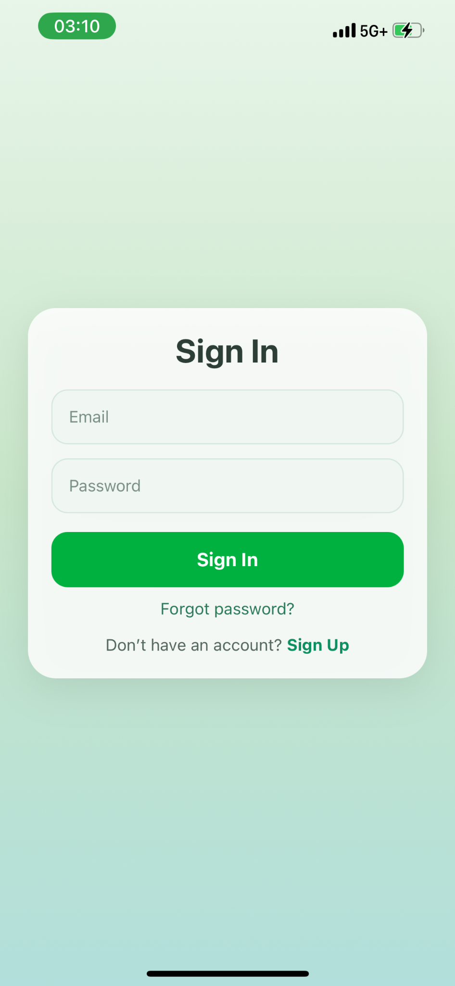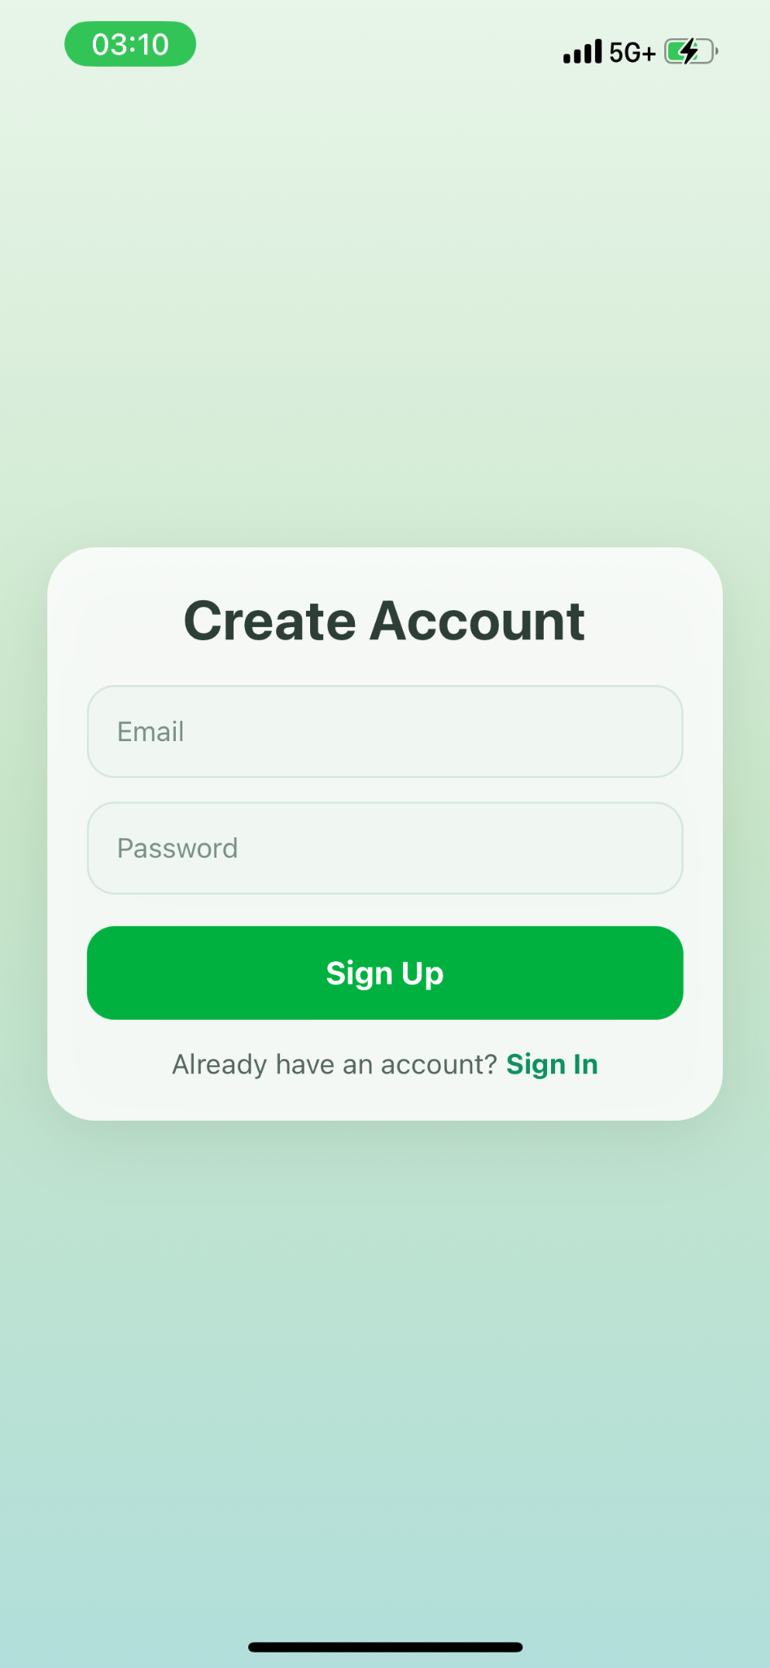

*Figure 1. Sign in and Create Account Pages*

## Homescreen

The Home screen acts as a hub for the student users. Key elements include a box breathing animation, a tip of the day, access to the settings page, and a clear view of the two other tab options.

The Home screen also initializes the new-user onboarding sequence, which presents a classroom-themed professor animation as seen in ***Figure 2***. This character introduces the basic functions of the app, explains how to interpret the budget graph, and guides the user through first-time tasks such as linking a bank account. This onboarding is enhanced with smooth fade-in transitions and is gated behind a one-time flag stored in Firestore.

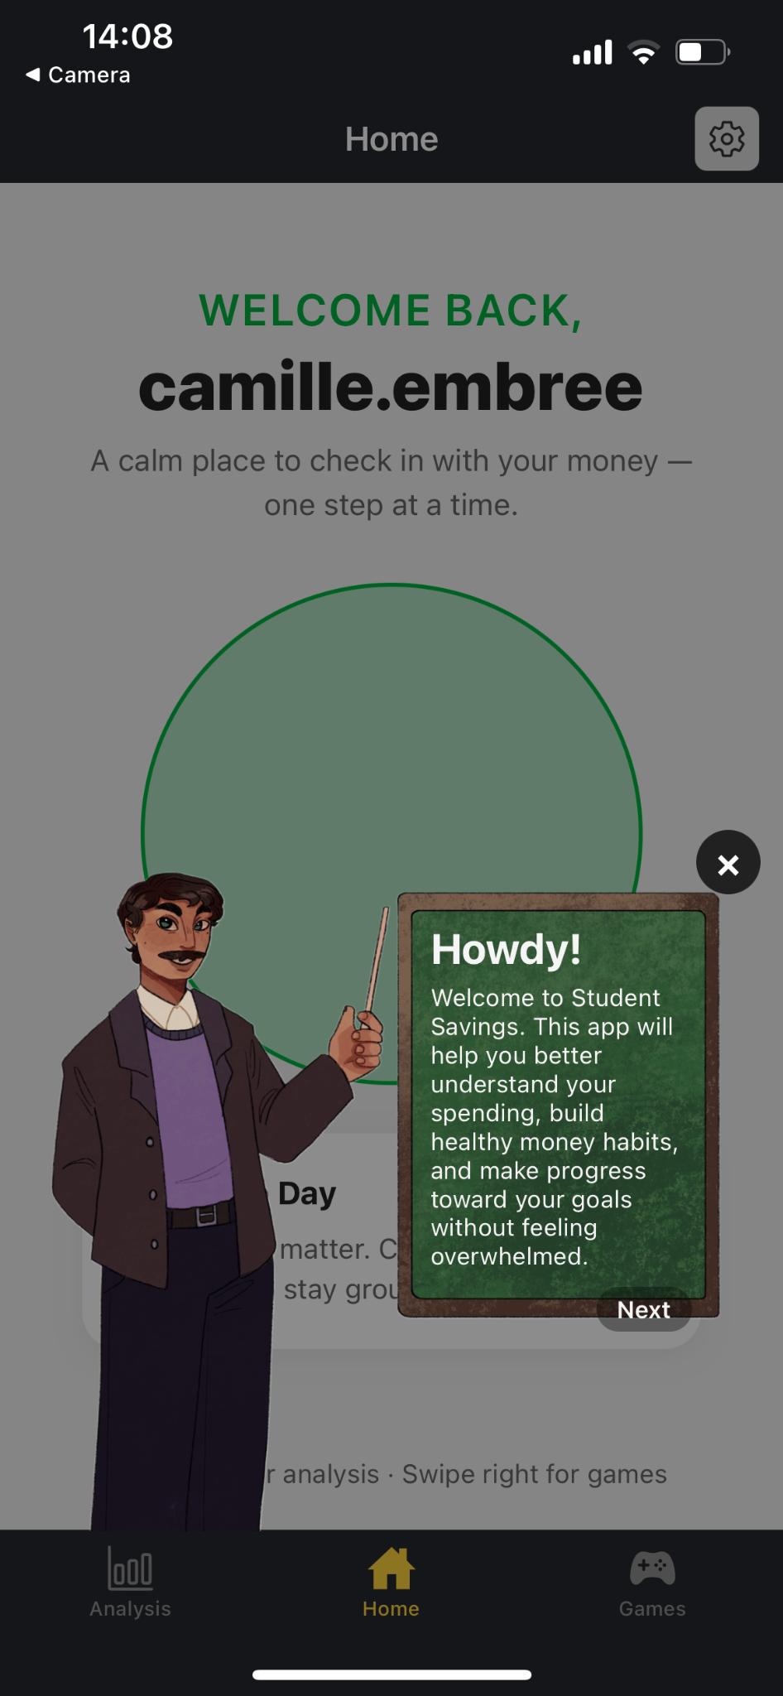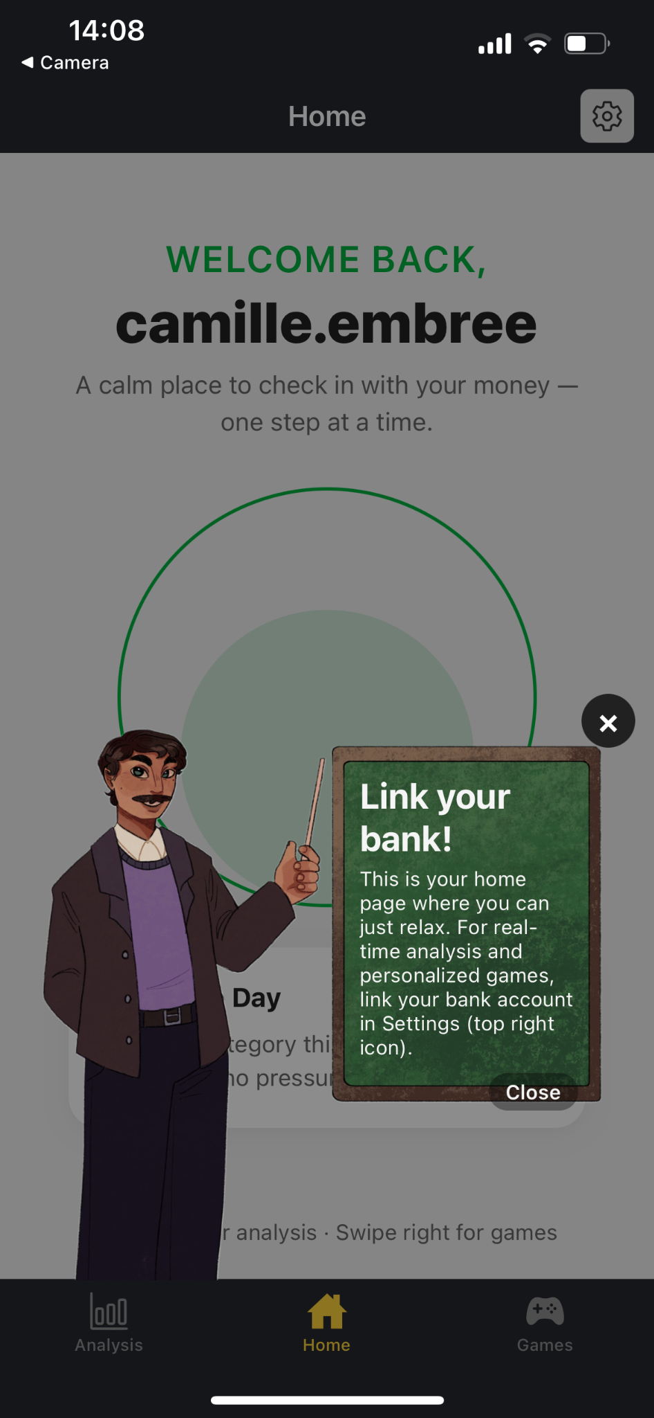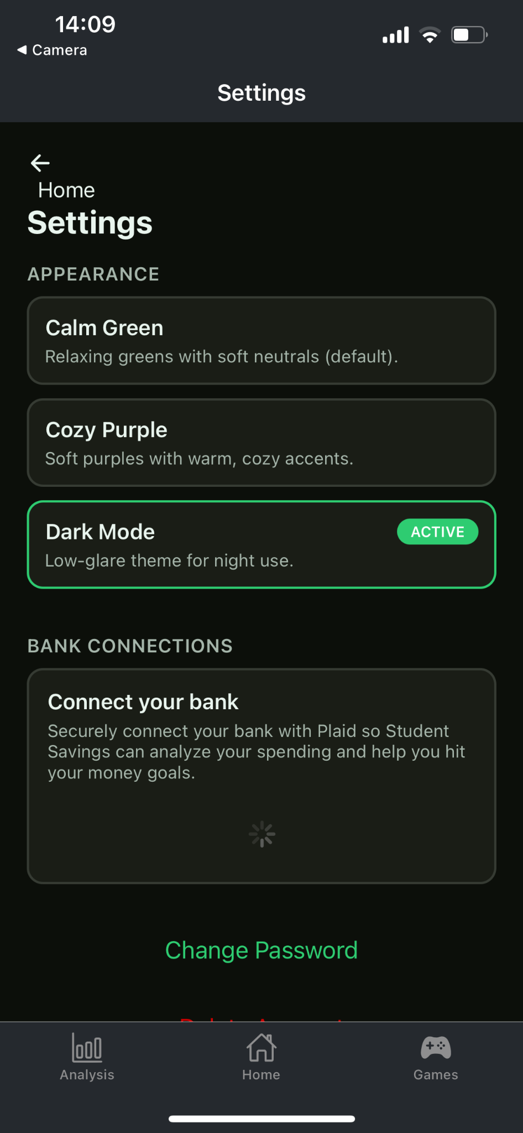

*Figure 2. Home Page Introduction and Settings Page*

## Analysis tab

The Analysis tab provides users with detailed financial insight through dynamically generated graphs and category breakdowns produced by backend analytics. Through a combination of line graphs, pie charts, and textual summaries, users can view spending patterns across configurable time ranges such as day, week, or month. They are also able to see a detailed graph of how far through their recommended monthly budget they currently are.

The frontend retrieves live updated analytics from the backend each time the tab is visited. A loading animation appears while API calls are in progress, ensuring that users never encounter incomplete or partially rendered data. Using this gathered data and libraries such as react-native-gifted-charts, three main graphs and one scrollable list is created.

Because analytics are dependent on Plaid-sourced transactions, the screen also includes visual cues prompting users to refresh their data or complete account linking if required.

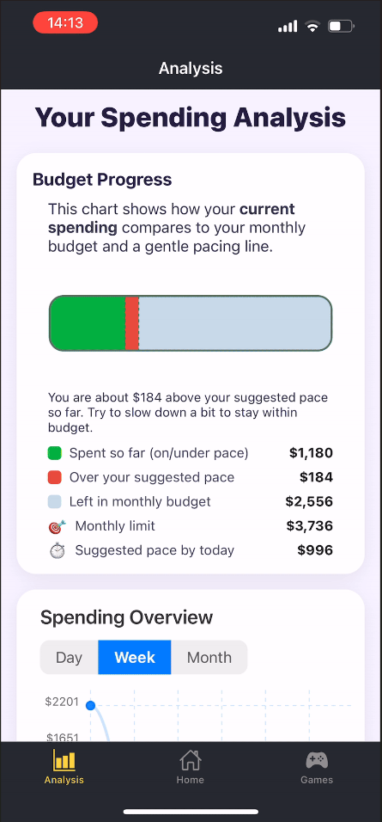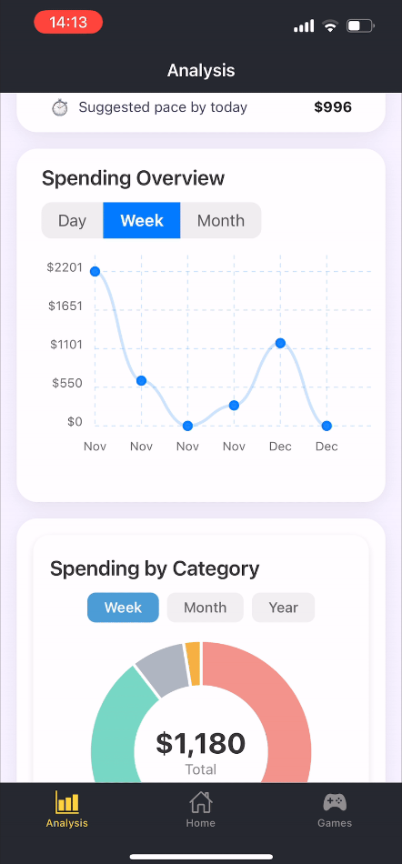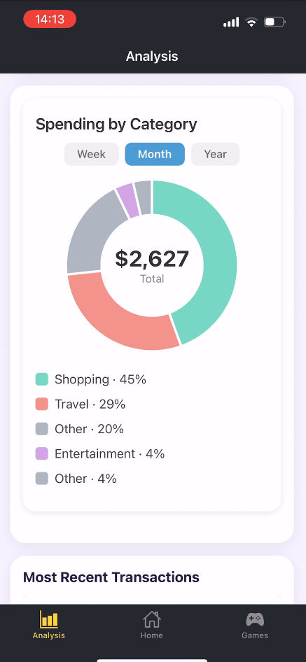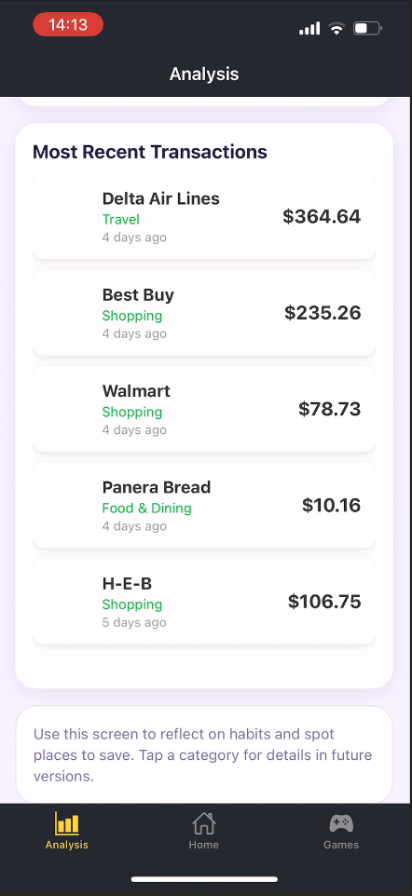

*Figure 3. Analysis page Layout*

## Games Tab

The Games tab acts as the gateway to the system’s financial literacy minigames: Smart Saver Quiz, Financial Categories, and Spend Detective. From this hub, users view their XP, current level, cooldown timers, and the availability of each game.

Each game initiates a structured interaction with the backend, which generates questions, validates answers, and updates the user’s progression. The frontend focuses on rendering interactive components, maintaining accessibility across screen sizes, and presenting scoring feedback in a clear and encouraging style.

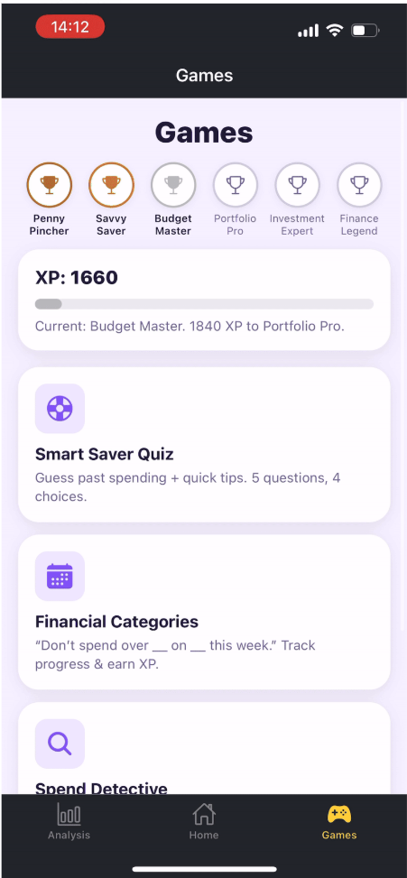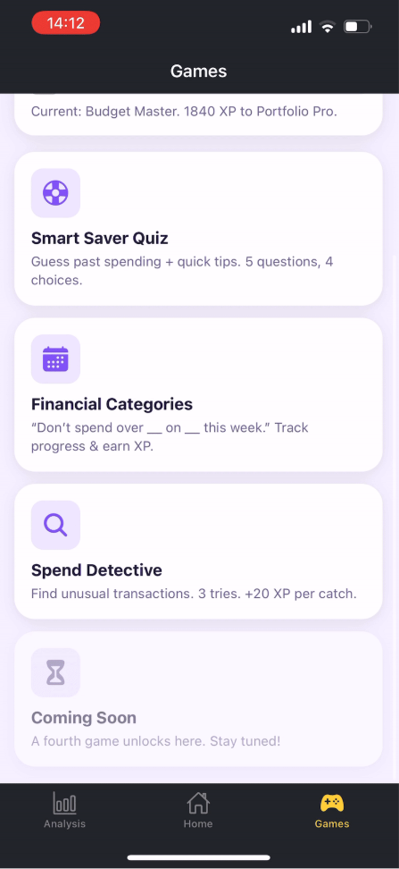

*Figure 4. Game Page Hub*

The Smart Saver Quiz is implemented as a multiple-choice trivia game that helps users build intuition about their own spending and general financial concepts. When the user starts a quiz, the frontend requests a new question set from the backend and renders each question sequentially with four possible answers, adapting its colors and typography to the currently selected app theme. For each question, the user selects an option and submits their answer, after which the UI displays immediate feedback indicating whether the response was correct along with a short explanatory note. At the end of the quiz, the frontend presents a results screen summarizing score, accuracy, XP gained, current level, and streak information, all returned from the backend. In low-data situations, where the user does not yet have enough transaction history to generate a personalized quiz, the screen instead shows a friendly message and awards a small amount of XP while encouraging the user to check back again. The quiz screen also updates the unified XP profile context so that progress is reflected consistently across the Games hub and the other minigames.

The Financial Categories game presents a connections-style matching interface where users pair spending categories with representative transaction amounts. When a round begins, the frontend calls the backend to determine whether the user is eligible to play and, if so, to retrieve a small, normalized board of categories and amounts derived from the user’s recent transactions. The UI displays the categories in one column and the amounts in another, and the user taps one tile from each side to propose a match. After the user submits a pair, the frontend sends the selection to the backend, which validates it and returns whether the match was correct, updates the remaining number of tries, and may reveal additional statistics such as XP earned and accuracy. Correct pairs animate into a “Solved” section at the top of the card, while incorrect attempts trigger brief visual feedback and reset the current selection. When the round ends—either because all pairs were solved or the user has exhausted their tries—the interface shows a summary panel and, when provided by the backend, a reveal list indicating the correct groupings and final XP, level, and streak values. In cases where the user has very low spending activity, the screen instead displays a congratulatory low-spend message and optional XP award rather than starting a full round.

Spend Detective is designed as an anomaly-spotting game where users practice identifying unusual transactions in their recent history. At the start of each round, the frontend calls the backend to request a curated list of transactions and any associated metadata needed for gameplay. The UI renders each transaction as a card showing merchant name, category, date, and amount, and instructs the user to select a single “suspect” before submitting. When the user submits a guess, the frontend sends the selected transaction identifier to the backend, which evaluates whether the choice corresponds to an anomalous transaction, updates the count of correct finds, remaining tries, and total anomalies, and returns updated XP and progression information. Correctly identified anomalies are visually locked in with a green, check-marked state, while incorrect guesses trigger a brief animated pulse to indicate error without ending the round immediately. Throughout the game, the interface displays compact pills summarizing tries remaining and anomalies found, and it uses a custom GIF loader while the round is initializing to maintain a polished user experience. Once the backend indicates that the round is complete—either because all anomalies have been found or the user has run out of tries—the frontend transitions to a completion view that summarizes accuracy, XP, level, streak, and a breakdown of correct, missed, and false-positive selections, along with optional feedback messages explaining the patterns behind the anomalies.

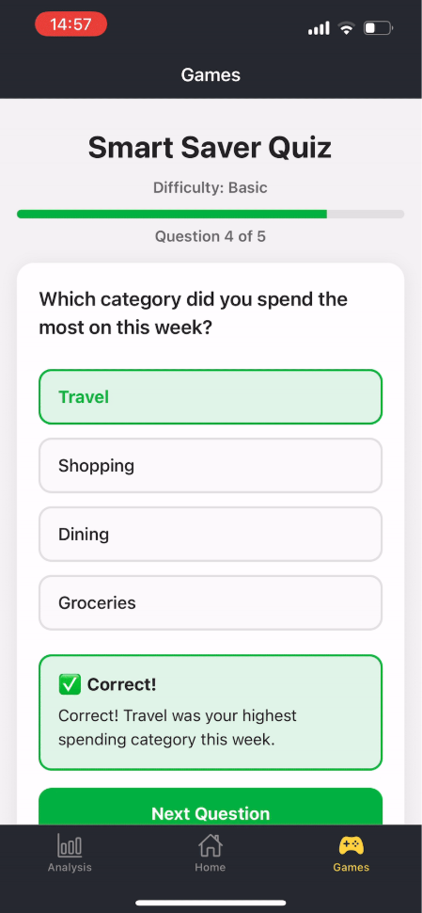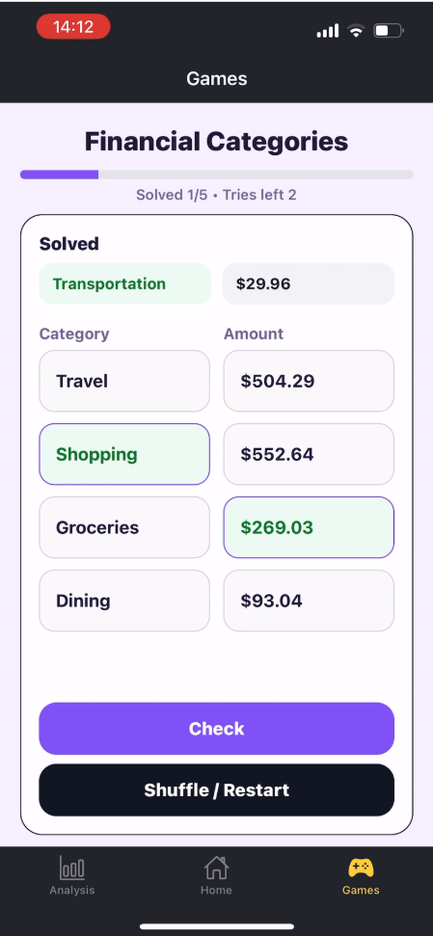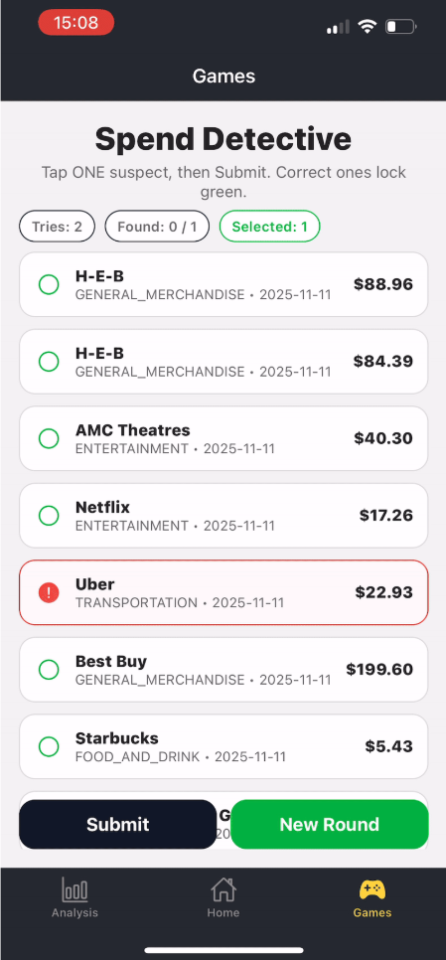

*Figure 5. Three Game Page Designs*

# API Communication

The redesigned system places the frontend in a strictly client-facing role, relying entirely on backend REST APIs for data retrieval and game logic. All requests include a Firebase ID token in the Authorization header to ensure secure, user-specific access.

The typical flow for API communication is that a user navigates to a screen (analysis page e.g.), the frontend retrieves the user’s personal Firebase ID token, send a GET or POST request to the backend, the backend verifies the token and processes the request, and a structured JSON is returned to render results. Some of the requests can be further explained in the Backend Subsystem section on page 128 in ***Tables 1-4***.

If an API request fails for any reason, a user will be alerted with a detailed error code. For example “missing Plaid connection,” “backend unavailability,” or “insufficient recent transactions for spend detective.” These messages are clear and concise to improve clarity and user experience.

1. **Plaid Link Frontend Integration**

The frontend integrates directly with Plaid Link, which provides a secure, guided flow for connecting financial accounts. When the user taps “Connect Bank” in settings, the frontend opens Plaid Link with configuration parameters supplied by the backend.

After the user completes the flow, Plaid returns a public_token, which the frontend immediately forwards to the backend. The application never stores or exposes sensitive bank credentials. The responsibilities of the frontend include launching the Plaid link UI, capturing the public_token, forwarding it to the backend, and displaying the confirmation or actionable errors.

Plaid link connection allows for users to witness real-time data without having to input manual entries for transactions.

1. **Extra UI Components**

To improve perceived performance and maintain coherence across different device speeds, the frontend includes several forms of animated feedback:

* 1. ***Loading Animations***

Custom GIF loaders appear when a user sends an API request and it’s still being fetched from the backend. Examples of these scenarios include analytics being fetched, game sessions being created, and transactions syncing into Plaid. Currently the custom GIF is of the professor character running to the left. Loaders have been positioned centrally on the screen with transparent backgrounds and writing describing the page being loaded directly below.

* 1. ***Professor Onboarding Animation***

As shown in ***Figure 2*** above, a distinctive onboarding flow introduces a cartoon-style professor who “teaches” new users about app features. The professor graphic slides into view with a chalkboard-style text box that explains graphs, introduces games, reminds users to link their bank, and provides closing navigation hints.

* 1. ***Color Palette Customization***

To enhance personalization and accessibility, the system includes a three-choice color palette that users may toggle within the Settings menu. Each palette adjusts primary accents, buttons, graph themes, and tab highlights. The current palette options include a comforting green to provide a calming finance-oriented visual identity, a vibrant purple to allow for a relaxing and higher energy, and a dark mode that includes bold contrast highlighting darker shades. Color themes propagate through the app using a centralized React context provider, ensuring that changes apply instantly across all tabs and screens. These options are available in the settings tab as shown in ***Figure 2*** above.

Financial Advisor App for Students

Hoang-Nghi Nguyen

**Backend Subsystem Report**

# Table of Contents

**1. List of Tables**  **73**

**2****. List of Figures**  **74**

**3****. Introduction**  **75**

**4****. Backend Subsystem Overview**  **76**

4.1. Objective  76

4.2. High-Level Architecture  77

4.3. Backend Technology Stack  79

4.4. Key responsibilities of the Backend  79

**5****. Authentication and Security**  **84**

5.1. Firebase Authentication Workflow  84

5.2. ID Token Verification Mechanism  86

5.3. User Identity Mapping in Firestore  88

5.4. Security Considerations  89

**6****. Plaid Bank Integration**  **91**

6.1. Objective of Plaid Integration  91

6.2. Linking Bank Accounts via Plaid Link  92

6.3. Token Exchange Process  95

6.4. Transaction Retrieval Workflow  96

6.5. Transactions Normalization & Storage Format  97

6.6. Error Handling  99

**7****. Firestore Database Design**  **102**

7.1. Firestore Structure  102

7.2. Read/Write Operations  104

7.3. Firebase Performance and Query Efficiency  106

**8****. Spending Analytics Engine**  **108**

8.1. Purpose of Analytics  108

8.2. Spending by Category  109

8.3. Spending Over Time  110

8.4. Budget Utilization Calculation  111

8.5. Analytics Endpoint Design  112

**9****. Minigame Engines**  **114**

9.1. Smart Saver Quiz  114

9.2. Financial Categories  116

9.3. Spend Detective  118

**10****. Experience & Leveling System**  **121**

10.1. XP/Level Model  121

10.2. Level Threshold Logic  121

10.3. Integration With All Minigames  123

**11****. API Design and Backend Endpoints**  **125**

11.1. Endpoint List  125

11.2. Request/Response Examples  130

11.3. Error Codes & Standardized Responses  134

11.4. Middleware Usage  137

# List of Tables

**Table 1.** Health and Utility Endpoints 128

**Table 2.** Plaid Bank Integration Endpoints 129

**Table 3.** Analytics Endpoints 130

**Table 4.** Minigame Service Endpoints 132

**Table 5.** Standard Backend Error Codes 134

# 

# List of Figures

**Figur****e 1. High-Level Backend Architecture Design**  78

**Figure 2. Firebase Authentication Workflow** 85

**Figure 3. Code for auth_middleware.py** 87

**Figure 4. Multi-Layer Security Model** 90

**Figure 5. Test Script for Plaid Connection 9**2

**Figure 6. Snippet of public exchange token from routes/plaid.py** 94

**Figure 7. Transaction Schema for an example account** 98

**Figure 8. Test for error handling with no public token** 101

**Figure 9. Result of error handling with no public token** 101

**Figure 10. User collection with user information** 102

**Figure 11. Transaction ID with filled records** 103

**Figure 12. Firebase performance test** 107

**Figure 13. Smart Saver Quiz Workflow** 115

**Figure 14. Financial Categories Workflow** 117

**Figure 15. Spend Detective Workflow** 120

**Figure 16. Route endpoints for analytics** 137

# Introduction

The backend subsystem serves as the core computational layer of the Personalized Financial Advisor application. It is responsible for authenticating users, securely retrieving financial data from external services, processing and storing transaction information, generating financial analytics, and executing the logic that powers the system’s gamified learning modules. All backend services are implemented in Python using the Flask framework and deployed on Google Cloud Run, enabling scalable, stateless, and highly available operation.

The subsystem interacts closely with Firebase Authentication and Firebase Firestore. Firebase Authentication provides secure identity verification through ID tokens, while Firestore functions as the persistent data store for user profiles, transaction records, progression metrics, and game state information. The backend validates every incoming request with Firebase credentials to ensure data is accessed and modified only by authorized users.

A central feature of the backend subsystem is its integration with Plaid, a financial data aggregation service used to retrieve real-world banking transactions. This integration allows the application to eliminate manual data entry and provide users with accurate, timely financial information. Retrieved transactions are normalized, categorized, and stored in Firestore, where they serve as the basis for analytics dashboards and for the Spend Detective and Financial Categories minigames.

In addition to financial data processing, the backend implements all gameplay logic through dedicated modules. These include question generation for Smart Saver Quiz, category validation and scoring for Financial Categories, anomaly generation and session management for Spend Detective, and progression updates for the application’s XP and leveling system. The backend ensures that game rules, scoring mechanisms, and weekly lockouts are enforced consistently across users.

The backend subsystem is designed with modularity, security, and scalability as primary considerations. Its architecture enables rapid request handling, consistent data integrity, and seamless integration with the mobile frontend. The following sections describe the backend architecture in detail, including authentication workflows, Plaid data ingestion, database schema design, analytics generation, game engine logic, API structure, deployment configuration, and validation results.

# Backend Subsystem Overview

* 1. ***Objective***

The objective of the backend subsystem is to provide a secure, reliable, and scalable computational foundation for the Personalized Financial Advisor application. The backend is responsible for managing all server-side logic, including user authentication, external financial data integration, transaction processing, financial analytics generation, and execution of the system’s gamified learning modules. Through seamless coordination with Firebase Authentication, Firebase Firestore, Plaid, and the React Native frontend, the backend ensures that users receive accurate financial insights and a consistent interactive experience.

The subsystem is designed to eliminate manual data entry by automating the retrieval and normalization of bank transactions, thereby improving usability and reducing the potential for human error. Additionally, it enables the application’s educational capabilities by hosting the logic for interactive financial-learning games and tracking user progression metrics such as experience points and levels.

In support of the system’s overarching goal to help students develop effective budgeting habits and financial literacy, the backend ensures data integrity, enforces application rules, and maintains performance under varying loads. Its architecture supports modularity, extensibility, and dependable operation across all application features.

## High-Level Architecture

The backend subsystem is designed as a stateless, modular service deployed on Google Cloud Run. It exposes a set of RESTful API endpoints through a Flask application, enabling the mobile frontend to perform authentication, retrieve financial data, access analytics, and participate in the system’s gamified learning modules. The architecture integrates three key external services: Firebase Authentication for user identity verification, Firebase Firestore for persistent data storage, and Plaid for secure financial data aggregation.

At a high level, all requests from the React Native frontend pass through an authentication middleware layer that verifies Firebase ID tokens before any backend logic is executed. Once authenticated, the backend routes requests to purpose-specific modules, including Plaid integration handlers, transaction processors, analytics generation routines, and minigame engines. These modules interact with Firestore to read or update user data as required.

Cloud Run enables the backend to operate in a serverless environment, automatically scaling based on traffic while maintaining isolation between instances. Because the service is stateless, all persistent information, including transactions, game state, and progression, is stored in Firestore, ensuring consistency across sessions regardless of backend instance lifecycle. This design increases system resilience, simplifies deployment, and maintains low operational overhead.

The architectural model emphasizes modularity, separation of concerns, and robustness. Each subsystem (authentication, Plaid retrieval, analytics, game logic) is encapsulated within its own set of modules, ensuring that changes in one area do not impact others. The result is an easily maintainable and extensible backend capable of supporting the application's growth and evolving functional requirements.



**Figure 1.** High-Level Backend Architecture Diagram

## Backend Technology Stack

The backend subsystem is implemented using a collection of modern, cloud-native technologies selected to ensure scalability, reliability, efficient development, and seamless integration with external services. The following components form the core of the backend technology stack:

### Flask (Python Web Framework)

The backend is built using Flask, a lightweight but highly extensible Python web framework. Flask enables rapid development of RESTful API endpoints and supports modular organization of authentication, Plaid integration, analytics, and game logic. Its simplicity allows the backend to remain maintainable while supporting complex application behavior.

### Google Cloud Run (Containerized Deployment Environment)

The Flask application is deployed on Google Cloud Run, a serverless compute environment that executes containerized workloads. Cloud Run provides automatic scaling, high availability, HTTPS support, and a fully managed runtime environment. Its stateless execution model aligns with the backend’s design, allowing each instance to serve requests independently while relying on Firestore for persistent data.

### Firebase Authentication

Firebase Authentication supplies secure identity verification through ID tokens generated on the mobile frontend. The backend validates these tokens for every protected request using Google’s public key infrastructure. This ensures that only authenticated users can access personal financial data or interact with game modules.

### Firebase Firestore (NoSQL Database)

All persistent application data—including user profiles, transaction records, game state, progression data, and Plaid access tokens—is stored in Firebase Firestore. Firestore’s document-based structure allows efficient querying and flexible schema evolution, while its strong consistency model ensures reliable data retrieval across backend instances.

### Plaid API (Financial Data Integration)

The backend uses Plaid to retrieve verified bank transactions and account metadata. Plaid enables secure linking of user bank accounts through the frontend's Plaid Link interface. The backend exchanges public tokens for long-lived access tokens, retrieves transaction data, and normalizes records before storing them in Firestore.

### Python Libraries and Utilities

Several supporting Python libraries are incorporated throughout the backend:

* **Requests** for API communication with Plaid
* **Google Cloud libraries** for Firestore and authentication token verification
* **Datetime and timezone packages** for budget and game session timing
* **Custom modules** (e.g., spend_detective.py, smart_saver_quiz.py, progression.py) for game logic and XP calculation

These packages support parsing, serialization, scheduling, state tracking, and integration tasks essential to backend operation.

### Containerization and Environment Management

The backend is packaged as a Docker container, enabling reproducible deployments and consistent execution across environments. Environment variables—including Plaid credentials, Firebase project identifiers, and Firestore paths—are securely injected into Cloud Run at runtime to protect sensitive information.

### RESTful API Structure

The backend exposes its functionality through a REST API design. Each endpoint adheres to consistent naming conventions and returns standardized JSON responses, facilitating predictable interactions with the frontend and simplifying debugging.

## Key Responsibilities of the Backend

The backend subsystem fulfills several essential responsibilities that collectively enable secure data handling, accurate financial analysis, and interactive learning features within the Personalized Financial Advisor application. These responsibilities span authentication, external service integration, persistent data management, analytics computation, and gamified behavior execution. Each responsibility is isolated within modular components of the backend, ensuring maintainability and reliability throughout system operation.

### Secure User Authentication

The backend verifies Firebase ID tokens for all protected API endpoints, ensuring that each request is associated with an authenticated user. This prevents unauthorized access to sensitive financial information and enforces identity-bound data isolation within Firestore.

### Financial Data Integration via Plaid

The backend manages the entire lifecycle of Plaid-related operations:

* Exchanging public tokens for long-lived access tokens
* Retrieving user transaction data
* Handling Plaid rate limits and partial-update scenarios
* Normalizing transaction payloads into a unified schema

This allows the system to provide accurate, up-to-date financial information without requiring manual input from the user.

### Transaction Normalization, Categorization, and Storage

Transactions retrieved from Plaid are converted into consistent document formats and stored in Firestore under the authenticated user's record. This includes mapping Plaid categories into the application's standard category groups and ensuring all transactions contain required fields for analytics and gameplay.

### Financial Analytics Computation

The backend computes financial insights requested by the frontend, including:

* Spending by category
* Total spending within defined date ranges
* Budget utilization based on stored user budget values
* Historical spending trends

The backend ensures that these analytics are derived from normalized Firestore data to maintain accuracy and consistency.

### Execution of Minigame Logic

The backend hosts the complete logic for all interactive learning modules:

* **Smart Saver Quiz:** question selection, answer validation, scoring, and feedback
* **Financial Categories:** transaction selection, category validation, scoring
* **Spend Detective:** anomaly generation, attempt tracking, win/loss conditions, and weekly lockout enforcement

All game actions modify or reference Firestore state to preserve gameplay continuity.

### User Progression and Leveling System

The backend manages XP accumulation and level progression across all minigames. It:

* Computes XP changes
* Stores progression data
* Enforces weekly reset logic
* Synchronizes progression values with the frontend

This system supports long-term user engagement and incentivizes consistent interaction with the application.

### Data Integrity and Persistence

All persistent information, including transactions, game attempts, anomalies, XP, and user metadata, is written to and retrieved from Firestore. The backend is responsible for ensuring:

* Atomic writes
* Consistent data schemas
* Valid state transitions
* Prevention of stale game sessions

### API Routing and Error Handling

The backend exposes RESTful endpoints organized by function. It handles:

* Validation of incoming data
* Error reporting in standardized JSON formats
* Graceful handling of invalid requests or missing data
* Logging of operational errors for debugging and monitoring

### Deployment, Scaling, and Environment Configuration

Through Google Cloud Run, the backend is deployed as a stateless containerized service. Responsibilities include:

1. Managing environment variables securely (Plaid keys, Firebase project IDs)
2. Ensuring scalability with traffic demand
3. Maintaining uptime and resilience across deployments

# Authentication and Security

## Firebase Authentication Workflow

The backend subsystem relies on Firebase Authentication as the authoritative mechanism for verifying user identity and securing access to financial and gameplay data. The mobile frontend is responsible for initiating user authentication and obtaining a Firebase ID token. This ID token is transmitted with every backend request, serving as the credential through which the backend verifies user identity.

When a request reaches the backend, the authentication middleware intercepts it before any business logic is executed. The middleware extracts the ID token from the request headers and validates it using Google’s public key infrastructure. This validation confirms the token’s signature, expiration time, issuer, and audience fields. If the token is missing, expired, or invalid, the backend rejects the request and returns an appropriate error response to the frontend.

Upon successful verification, the middleware extracts the Firebase user identifier (UID), which uniquely associates the request with a specific Firestore user document. All backend modules (Plaid integration, analytics, game logic, and progression) use this UID to ensure that every operation is executed on the correct user’s data. This architecture guarantees strict isolation between users and prevents unauthorized access to financial transactions, game state, or XP progression.

By delegating identity verification to Firebase and performing token validation on every request, the backend maintains a secure, stateless design. No session storage is required, and Cloud Run instances can scale independently without loss of authentication context. This approach ensures secure operation while minimizing complexity in the backend subsystem.



**Figure 2.** Firebase Authentication Workflow

## ID Token Verification Mechanism

The backend subsystem employs a standardized ID token verification process to ensure that only authenticated users can access protected resources. This mechanism is implemented in the auth_middleware.py module, which intercepts all incoming requests to protected API endpoints before business logic is executed.

When a request is received, the middleware extracts the Firebase ID token from the Authorization header. The backend uses Google’s public key infrastructure (JWKS) to validate the token's signature and confirm its authenticity. The verification process includes several checks:

1. **Token Signature Validation** The backend verifies that the token was signed by a trusted Google private key corresponding to the public key published in Firebase’s JWKS endpoint.
2. **Expiration Check** The backend examines the token’s exp field to ensure that it has not expired. Expired tokens are immediately rejected.
3. **Issuer and Audience Validation** The backend verifies that the iss (issuer) and aud (audience) fields match the expected Firebase project configuration, preventing cross-project token misuse.
4. **User Identity Extraction** Once validated, the middleware extracts the uid field from the token. This UID uniquely identifies the authenticated user in Firebase Authentication and Firestore.

If any validation step fails, the middleware returns an error response to the client, preventing the request from reaching application logic. If validation succeeds, the middleware attaches the UID to the request context so downstream modules, such as analytics, Plaid integration, or minigame logic, can operate securely on the correct user’s data.

This stateless authentication model provides scalability and security across all backend instances. Since Cloud Run services do not maintain persistent sessions, verifying every request via ID token ensures consistent identity enforcement regardless of deployment state or instance lifecycle. This approach protects the integrity of user data and prevents unauthorized access to financial or gameplay information.

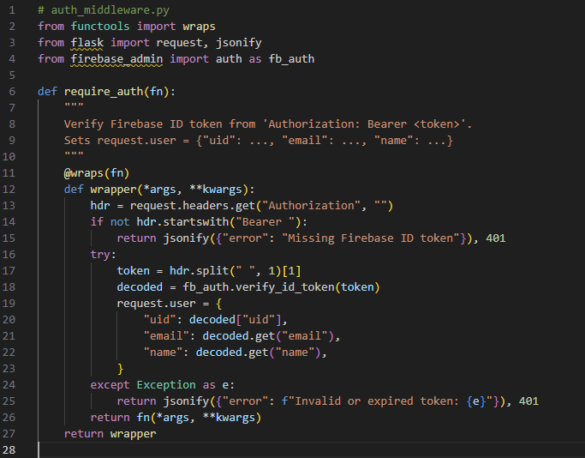

**Figure 3.** Code for auth_middleware.py

## User Identity Mapping in Firestore

The backend subsystem uses the Firebase Authentication user identifier (UID) as the primary key for mapping all application data to the appropriate user within Firestore. Once an ID token has been validated by the authentication middleware, the extracted UID becomes the authoritative reference for all backend operations, ensuring data isolation and preventing cross-user data access.

Upon first interaction with the system, the backend initializes a Firestore document for the authenticated user under the users collection. This document stores user-level metadata, including Plaid access tokens, budgeting settings, progression values, and timestamps. All additional user data, such as transactions or game-related state, is stored in structured subcollections beneath the user’s main document. This hierarchical mapping guarantees that each user’s data is logically grouped and accessible only through their associated UID.

During financial data ingestion, the backend retrieves the correct Firestore path using the UID and stores normalized transactions under users/{uid}/transactions. When a minigame is executed, the backend retrieves and updates the appropriate documents under users/{uid}/game_state or related subcollections. This ensures that game sessions, XP progression, and weekly lockouts operate independently for each user.

Because the backend is deployed on Google Cloud Run as a stateless service, UID-based data organization ensures consistent behavior regardless of which backend instance handles a given request. Each request contains all information required to reconstruct the user context, eliminating session dependency and improving scalability. The UID-based mapping strategy is central to maintaining data integrity, preventing unauthorized access, and supporting the application's interactive, personalized user experience.

## 

## Security Considerations

The backend subsystem is designed with strict security controls to protect user financial data, maintain system integrity, and ensure compliance with both Firebase and Plaid requirements. Security is enforced at multiple layers within the architecture, including communication channels, authentication, data storage, and external service integration.

### Secure Communication (HTTPS Enforcement)

All traffic between the mobile frontend and the backend is transmitted over HTTPS. Google Cloud Run enforces Transport Layer Security (TLS) by default, ensuring that API requests, authentication tokens, and sensitive financial information cannot be intercepted or modified during transmission. This protects against common threats such as man-in-the-middle attacks and packet sniffing.

### Token Expiry and Revocation Handling

Firebase ID tokens include built-in expiration timestamps and signature verification requirements. The backend verifies these constraints for every request, ensuring that expired or revoked tokens cannot be used to access protected resources. This prevents session hijacking and enforces time-bound access control. Additionally, since the backend is stateless, no long-term sessions are stored on Cloud Run instances, reducing exposure to session-based attacks.

### Authorization and Data Isolation

User identity, represented by a Firebase UID, is used to scope all Firestore operations. The backend performs UID-based filtering to ensure that users can only access their own data. Firebase Security Rules complement this behavior by blocking unauthorized reads or writes at the database level, even if malformed or unauthorized requests reach Firestore.

### Sensitive Credential Management

The backend uses environment variables stored securely in Google Cloud Run for Plaid credentials, Firebase configuration parameters, and other confidential values. These secrets are not stored in source code or distributed to the client. Cloud Run prevents unauthorized retrieval of environment variables, ensuring that financial API keys remain secure.

### Plaid Compliance Requirements

Plaid mandates strict handling of financial access tokens and prohibits exposure of sensitive banking details. The backend adheres to these requirements by storing Plaid access tokens only in Firestore under each user's UID, and by retrieving only transaction metadata—not full account numbers or credentials. All Plaid interactions occur server-side, and the backend sanitizes any Plaid response before returning it to the frontend.

### Validation and Error Handling

The backend uses structured error responses to prevent accidental disclosure of system internals. Errors that arise during token verification, Plaid communication, or Firestore operations are logged securely but reported to the frontend only in generic terms. This reduces the attack surface by minimizing information disclosure.

### Isolation and Stateless Execution

Because Cloud Run instances are stateless and ephemeral, they store no persistent data locally. This eliminates long-term data exposure risks and ensures that even if an instance fails or is decommissioned, no sensitive information remains on the compute environment.

Collectively, these security mechanisms ensure that the backend subsystem operates with strong confidentiality, authenticity, and integrity guarantees, enabling safe handling of financial data and secure user interactions throughout the application.



**Figure 4.** Multi-Layer Security Model

# Plaid Bank Integration

## Objective of Plaid Integration

The objective of the Plaid integration subsystem is to provide the application with a secure, automated, and reliable method for retrieving financial transaction data directly from a user’s banking institution. This eliminates the need for manual entry or receipt uploads and ensures that all analytics, budgeting tools, and gamified learning modules operate on accurate, real-world financial information.

Plaid serves as the intermediary between the user’s bank and the backend subsystem. By linking financial accounts through Plaid’s frontend authentication flow, the system gains access to verified transaction histories without exposing sensitive banking credentials to the backend or mobile client. Once a user completes the Plaid Link process, the backend exchanges the generated public token for a secure access token and uses it to fetch transaction data as needed.

The integration supports several system objectives:

* **Automated Data Ingestion:** Provides seamless retrieval of a user’s recent transactions, reducing user burden and improving data reliability.
* **Data Accuracy:** Ensures spending analytics and budget calculations reflect true financial behavior.
* **Secure Communication:** Maintains strict compliance with banking security standards while preventing direct exposure of user credentials.
* **Real-Time Operation:** Enables the backend to refresh transaction data on demand, keeping dashboards and minigames current.
* **Support for Gamification:** Supplies the Spend Detective and Financial Categories games with structured transaction data required for anomaly detection and financial learning.

By establishing Plaid as the system’s primary financial data source, the backend achieves consistent data quality, robust authentication, and strong security guarantees. This integration is fundamental to delivering a fully automated, user-friendly financial advisor experience.

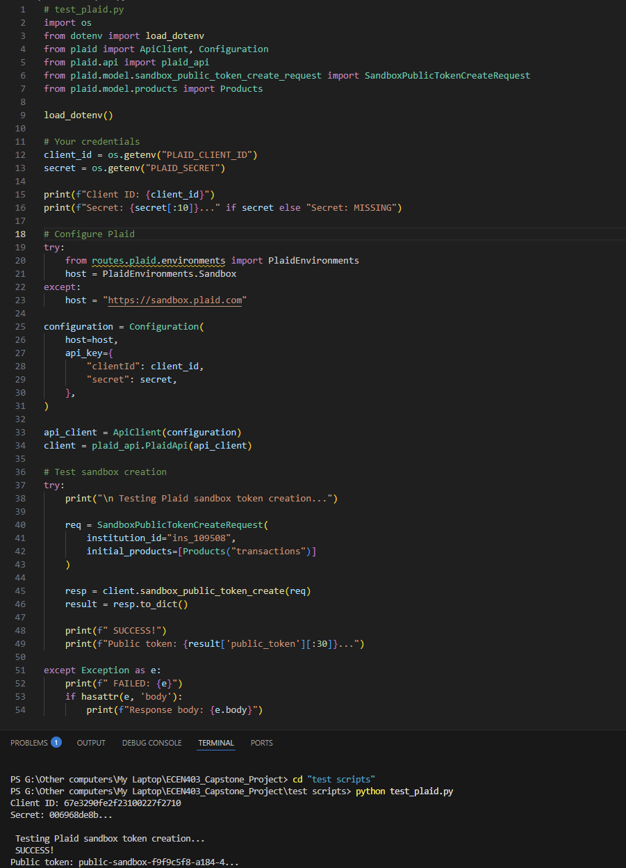

**Figure 5**. Test Script for Plaid connection

## Linking Bank Accounts via Plaid Link

The Plaid Link process provides the secure and user-friendly interface through which individuals connect their financial institutions to the Personalized Financial Advisor application. This workflow begins within the mobile frontend, which launches the Plaid Link module: a prebuilt, bank-grade authentication interface provided by Plaid.

During this process, the user selects their bank, enters their credentials, and completes any required multi-factor authentication. All sensitive information is transmitted directly to Plaid and never exposed to the frontend application or backend server. Upon successful authentication, Plaid returns a **public token** to the frontend. This token acts as a temporary credential that confirms the user has granted permission for the system to access their financial data.

The frontend then forwards the public token and the user's Firebase ID token to the backend. The backend exchanges the public token for a long-lived **Plaid access token**, which allows the system to retrieve transaction data on behalf of the user. This access token is securely stored under the authenticated user's document in Firestore and is never returned to the client. From this point forward, the backend can request updated transactions without requiring the user to re-authenticate with their bank.

This workflow offers several advantages:

* **Security:** User credentials never touch the application or backend; Plaid handles all sensitive authentication.
* **Convenience:** Users link their bank account once and continue to receive updated financial data without repeated logins.
* **Compliance:** Access tokens are stored securely and used in accordance with Plaid’s data-handling requirements.
* **Reliability:** Plaid’s infrastructure ensures consistent and accurate retrieval of financial data from supported institutions.

The successful completion of the Plaid Link workflow is essential for the operation of the spending analytics engine, budget tracking features, and the minigames that rely on real financial transactions.

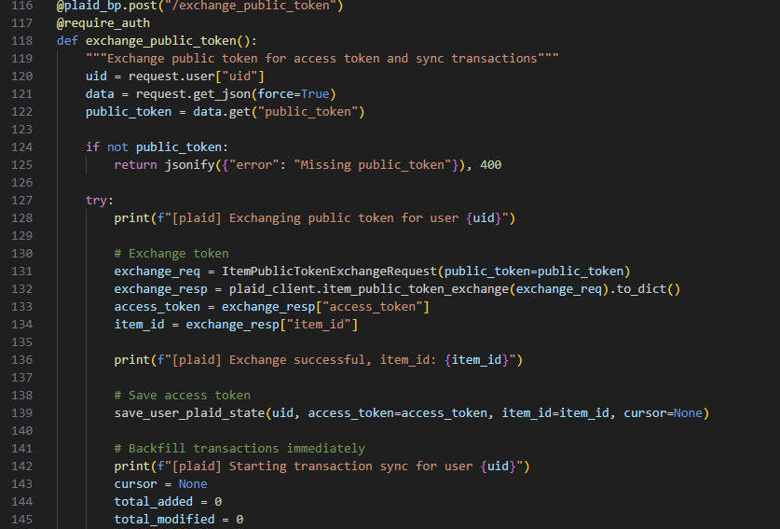

**Figure 6.** Snippet of public exchange token from routes/plaid.py

## Token Exchange Process

After a user successfully links a financial institution through Plaid Link, the frontend receives a short-lived public_token that represents the user’s consent to access their financial data. The backend subsystem is responsible for converting this public_token into a long-lived access_token that can be used to retrieve transactions on behalf of the user.

When the frontend completes the Plaid Link flow, it sends a request to the backend containing the public_token and the user's Firebase ID token. The backend first verifies the ID token through the authentication middleware to ensure that the request originates from an authenticated user. Once the user has been validated and the UID is available, the backend proceeds with the token exchange.

The backend submits a request to Plaid’s /item/public_token/exchange endpoint, passing the public_token along with the system’s Plaid client_id and secret. Plaid validates the public_token and, if successful, returns an access_token and an associated item_id. The access_token is a long-lived credential that allows the backend to request account and transaction information for that item without requiring the user to re-authenticate.

The backend stores the access_token under the authenticated user’s document in Firestore, typically in the users/{uid} document along with other integration metadata. The public_token is not stored and cannot be reused after the exchange. All subsequent calls to Plaid for transaction retrieval use the stored access_token rather than the original public_token.

Error handling is an important part of the token exchange process. If the public_token is invalid, expired, malformed, or the Plaid API returns an error, the backend responds to the frontend with a clear failure status and does not store any token in Firestore. This prevents the system from persisting unusable access tokens and alerts the frontend to prompt the user to retry the linkage process if needed.

This token exchange workflow ensures that the backend holds only the minimum required credential (the access_token) to retrieve financial data securely and that all sensitive authentication steps are handled exclusively through Plaid’s infrastructure and the frontend Plaid Link interface.

## Transaction Retrieval Workflow

Once an access_token has been securely stored for an authenticated user, the backend subsystem is able to retrieve financial transaction data from Plaid on demand. This process is central to the operation of the application, as normalized and up-to-date transaction records provide the foundation for analytics, budgeting tools, and multiple minigame engines.

The transaction retrieval process begins when the frontend requests updated financial data, typically during app launch, dashboard refresh, or analytics access. The backend first validates the user’s Firebase ID token and extracts the UID. Using this UID, the backend retrieves the stored Plaid access_token from the corresponding Firestore user document.

With the valid access_token, the backend issues a call to Plaid’s /transactions/get endpoint. This request includes the desired date range, such as the last 30 days, enabling the backend to limit the response size and optimize performance. Plaid returns a structured list of transaction objects that include the merchant name, amount, timestamp, category information, currency code, and additional metadata.

Upon receiving the transaction data, the backend performs normalization to maintain consistency across all records. This includes ensuring field types match internal schemas, interpreting Plaid category arrays into the application’s high-level spending categories, converting timestamps to a unified format, and removing or adjusting any optional fields that may be missing from Plaid responses. Each normalized transaction is stored as a separate document under users/{uid}/transactions, where the document ID is typically the transaction ID returned by Plaid or a generated identifier.

The backend ensures idempotency during storage by overwriting or merging records only when necessary. This prevents duplicate entries and ensures the Firestore dataset remains clean and predictable. If Plaid indicates new transactions are available, the backend updates only the subset of documents that correspond to new or modified entries.

Error handling is an integral component of the retrieval workflow. If the Plaid request fails due to rate limits, outdated access tokens, temporary outages, or malformed input, the backend returns a structured error response to the frontend and does not modify stored transaction data. This ensures that the application operates on consistent information even during network or service interruptions.

The transaction retrieval workflow supports scalable and secure access to user banking data while maintaining a clean and uniform data structure suitable for downstream analysis and interactive financial learning modules.

## Transaction Normalization & Storage Format

After retrieving transaction data from Plaid, the backend subsystem performs a normalization process to ensure that all stored financial records follow a unified schema suitable for downstream analytics, budget calculations, and gameplay logic. Plaid’s transaction objects may vary in structure depending on institution, account type, or data availability. Therefore, normalization serves to standardize fields, reduce missing-data variability, and align each transaction with the application's internal representation.

The normalization pipeline begins by extracting essential fields from the Plaid transaction payload, including the merchant name, transaction amount, date, currency code, category list, and Plaid’s unique transaction identifier. The backend converts all date fields into a consistent ISO 8601 format and ensures that numeric values such as amounts are stored as floating-point values. Merchant names are trimmed and sanitized to prevent inconsistencies caused by whitespace or formatting differences.

A key part of normalization is transforming Plaid’s multi-level category array into the high-level spending categories used by the application. For example, Plaid may classify a transaction as ["Food and Drink", "Restaurants"], but the application maps this to a broader category such as "Dining" or "Food". This mapping ensures that analytics, pie charts, and the Financial Categories game operate on meaningful, cohesive category groupings.

Once normalized, each transaction is stored in Firebase Firestore under the authenticated user’s transaction subcollection at the path users/{uid}/transactions/{txn_id}. The backend uses Plaid’s transaction ID as the Firestore document ID when available, ensuring idempotent writes—meaning repeated sync operations will update existing documents rather than create duplicates. Additional metadata such as timestamps, category scores, or gameplay hints may be added in future iterations without altering core schema compatibility.

This standardized transaction structure enables seamless integration with the analytics engine, which relies on uniform fields for aggregation and computation. It also supports the Spend Detective and Financial Categories minigames, both of which assume consistent naming conventions and category assignments.

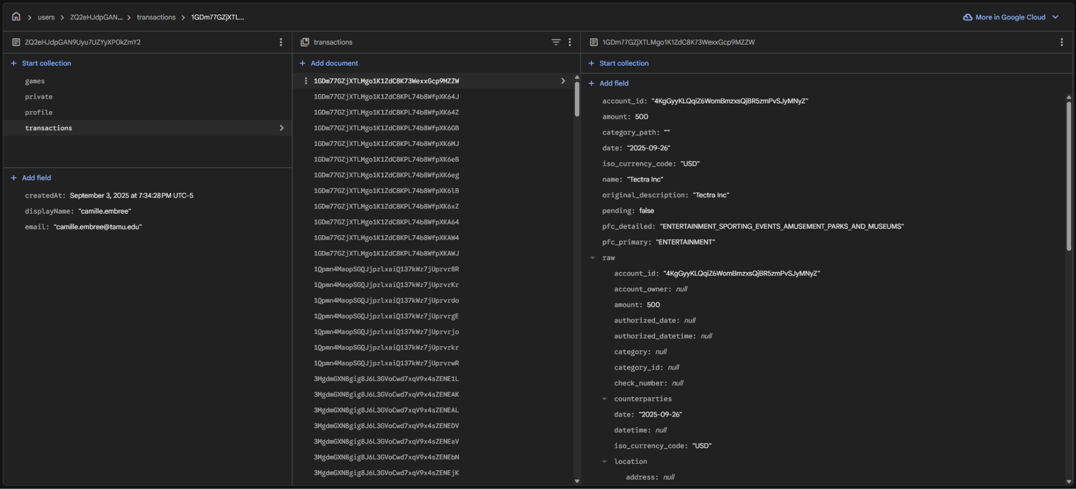

**Figure 7.** Transaction Schema for an example account

Normalization was verified by manually inspecting Firestore documents after transaction synchronization and confirming that all required schema fields were present, consistently formatted, and correctly categorized.

## Error Handling

Robust error handling is essential for ensuring that the backend subsystem remains stable and predictable during interactions with external services such as Plaid and Firebase Firestore. Because financial data retrieval and storage operations depend on network availability, API correctness, and user authentication, the backend is designed to detect and handle errors gracefully while preventing corruption of user data and maintaining a consistent application state.

### Invalid or Missing Authentication Tokens

If a request arrives without a Firebase ID token, or if the token is invalid or expired, the authentication middleware immediately rejects the request and returns a structured JSON error response with an HTTP 401 status code. This prevents unauthorized access to sensitive financial or gameplay data and ensures that the backend operates only on verified user identities. The backend does not process any business logic until authentication is complete.

### Invalid or Expired Plaid Public Tokens

During the Plaid token exchange process, the backend may receive malformed or expired public tokens from the client. In such cases, the Plaid /item/public_token/exchange endpoint returns an error response, which the backend forwards to the client with an appropriate 400-level status code. The backend does not store any access token if the exchange fails, preserving data integrity and preventing downstream failures.

### Invalid or Expired Plaid Access Tokens

If an access token stored in Firestore becomes invalid, whether due to user revocation, Plaid sandbox item resets, or migration events, the backend handles the error by returning a structured error response indicating that the user must re-link their bank account. No incorrect or empty transaction data is written to Firestore. This ensures that analytics and gameplay modules do not operate on incomplete or compromised data.

### Plaid Rate Limits and Temporary Outages

Plaid may return error responses for rate-limiting events, upstream banking issues, or temporary service disruptions. The backend detects these conditions and responds with fallback behavior:

* No modification is made to Firestore transaction records
* A clear error message is returned to the frontend
* The frontend may surface a retry prompt or fallback state

This avoids inconsistent or partially updated transaction datasets and preserves the accuracy of budget tracking and analytics.

### Malformed or Unexpected Plaid Responses

Because Plaid’s category depth, merchant naming, and metadata fields may vary across institutions, the backend includes defensive checks to ensure that missing or malformed fields do not cause application crashes. Default values are assigned when necessary, and any non-critical anomalies are logged for debugging while allowing continued operation.

### Firestore Read/Write Failures

Firestore operations may fail due to latency spikes, permission rule mismatches, or network interruptions. In such cases:

* Write operations are retried only if safe
* Failed writes do **not** overwrite existing data
* Reads that fail produce a structured error passed to the frontend
* Critical errors are logged in Cloud Run for traceability

This design prevents partial writes, race conditions, and inconsistent state transitions in user progression and game state.

### Gameplay Error Isolation

Each minigame (Smart Saver Quiz, Financial Categories, Spend Detective) includes isolated error handling to ensure that a failure in one module does not affect the others. If a game session fails due to missing transactions or Firestore issues, the backend returns a defined error state to the frontend rather than allowing the game to proceed in an invalid state.

### Structured JSON Error Responses

To enable consistent client-side behavior, the backend formats all error responses in standardized JSON structures that include:

* error: human-readable message
* code: optional error subtype
* details: optional debug metadata (not exposed in production)

This standardization allows the frontend to reliably interpret and display errors across all screens.

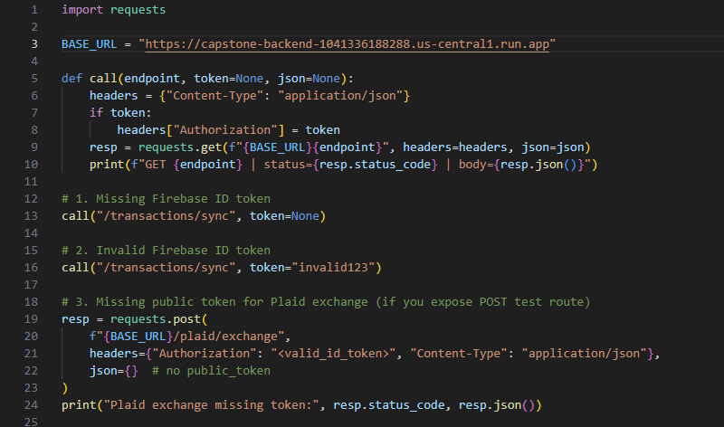

**Figure 8.** Test for error handling with no public token

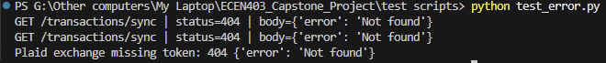

**Figure 9.** Result of error handling with no public token

Error handling behavior was validated using targeted API calls that intentionally omitted or corrupted required inputs. Requests without Firebase ID tokens and requests containing invalid tokens were correctly rejected with HTTP 401 responses by the authentication middleware. Similarly, attempts to exchange a missing or malformed Plaid public token resulted in HTTP 400 responses with structured JSON error messages. These tests confirm that the backend subsystem enforces authentication, preserves data integrity, and fails safely under error conditions.

# Firestore Database Design

## Firestore Structure

Firestore is organized around a top-level users collection, where each document corresponds to a Firebase-authenticated user and is identified by that user’s UID. This document stores high-level profile data and integration metadata. Additional application-specific data, such as bank transactions, minigame state, and progression metrics, is organized into subcollections beneath each user document.

At a high level, the structure is:

* users/{uid} – root document for each user
  + profile fields (budget, level, XP, configuration)
  + plaid_access_token field
  + transactions subcollection
  + game_state subcollection (per-game documents)

This structure enforces a clean boundary between users and provides a straightforward path for all backend modules to locate and update relevant data using the UID obtained from Firebase Authentication.

### Users Collection

The users collection is the entry point for all user-related data. Each document is keyed by the Firebase UID and contains metadata and configuration fields needed by the backend:

* budget: numeric field representing the user’s current budget target
* xp: total experience points accumulated from all minigames
* level: current user level as determined by the progression system
* plaid_access_token: encrypted or plain access token used for Plaid API calls (stored server-side only)
* created_at and last_login: timestamps for auditing and analytics

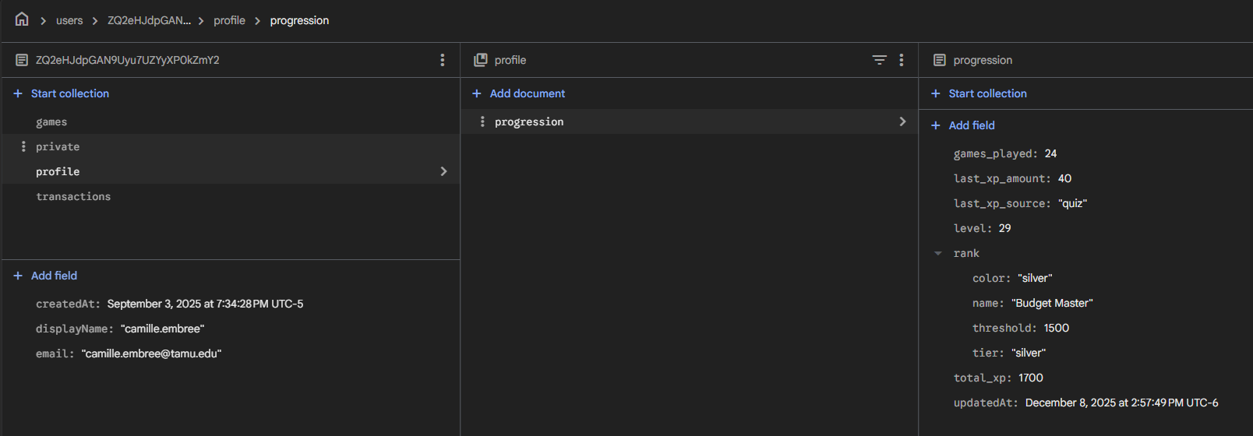

**Figure 10.** User collection with user information

### Transactions Subcollection

Each user document includes a transactions subcollection that stores normalized transaction records. The backend writes one document per transaction at the path users/{uid}/transactions/{txn_id}. This subcollection is the primary data source for the analytics engine and two of the minigames (Financial Categories and Spend Detective).

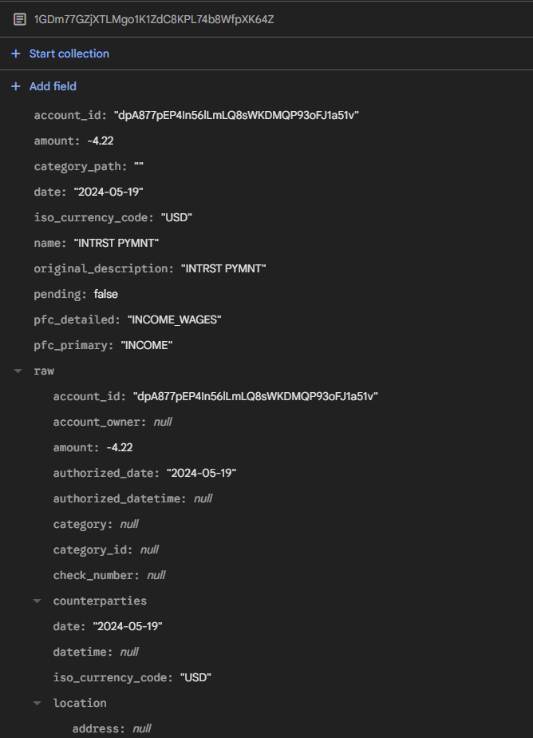

**Figure 11.** Transaction ID with filled records

## Read/Write Operations

The backend subsystem interacts with Firestore through a combination of read and write operations that support user authentication, transaction synchronization, analytics computation, minigame execution, and progression tracking. Because Cloud Run instances are stateless, all persistent information must be written to and retrieved from Firestore in a controlled and consistent manner. This section describes how these operations are performed and how they support the functioning of the application.

### Read Operations

Read operations are primarily used to retrieve user configuration, access tokens, transaction datasets, and game-related metadata.

**Key read operations include:**

* **User Profile Retrieval:** The backend reads the root user document (users/{uid}) to obtain fields such as budget, XP, level, and Plaid access tokens.  
   These values are required for analytics and Plaid communication.
* **Transaction Retrieval:** Queries to users/{uid}/transactions allow the backend to gather:
  + All transactions within a date range
  + Recent transactions for minigames
  + Category-specific data for analysis  
     Firestore’s indexed querying supports efficient filtering by fields such as date.
* **Game State Retrieval:** The backend reads from users/{uid}/game_state to enforce:
  + Weekly lockouts (Spend Detective)
  + Quiz attempts or accumulated metrics
  + Last played timestamps  
     This ensures minigame logic remains consistent across sessions.

Because Firestore provides strong consistency guarantees for individual documents, these read operations reliably reflect the latest committed user state.

### Write Operations

Write operations store updated user data into Firestore following analytics calculations, Plaid synchronization, or game events.

**Key write operations include:**

* **Storing Plaid Access Tokens:** When the backend exchanges a public_token for an access_token, the resulting credential is written to the user document.
* **Saving Normalized Transactions:** Each Plaid transaction is written as a document under users/{uid}/transactions/{txn_id}.  
   Overwrites occur only when updates are detected, ensuring idempotency.
* **Updating Game State:** The backend writes:
  + Updated timestamps
  + Game results (e.g., wins, losses)
  + Weekly lockout indicators
  + Progress updates  
     These writes ensure that the frontend always displays accurate game availability and feedback.
* **Progression Tracking Writes:** After completing a minigame, the backend updates fields such as xp and level in the user document.  
   These writes use merge operations to avoid overwriting unrelated fields.

All write operations are structured to prevent data corruption, ensure atomicity on a per-document level, and maintain compatibility with Firestore’s security rules.

### Performance Considerations

Firestore operations are optimized through:

* **Document-level granularity:** Transactions are stored individually to avoid large document reads.
* **Indexed queries:** Queries using date filters or category filters are efficient due to Firestore indexing.
* **Minimal write frequency:** Backend modules avoid unnecessary rewrites by checking whether data has changed (e.g., transaction normalization always checks timestamps or IDs).

This design ensures low latency and predictable performance across backend modules.

### Error Handling During Reads/Writes

Read or write failures (due to permission issues, network errors, or rate limits) are handled by:

* Returning structured JSON errors
* Logging failure details to Cloud Run
* Preventing partial updates or inconsistent user state
* Preserving previously written valid data

This behavior supports data integrity and reliability even under adverse network conditions.

## Firebase Performance and Query Efficiency

The performance of the backend subsystem depends heavily on the efficiency of Firestore read and write operations, as these operations occur during transaction synchronization, analytics generation, and minigame execution. To ensure low latency and scalability, the backend is designed to minimize the volume of data transferred, reduce redundant queries, and leverage Firestore’s built-in indexing capabilities.

### Query Efficiency

Firestore supports indexed queries on document fields, enabling the backend to efficiently retrieve subsets of user data. The backend takes advantage of this by:

* Querying transactions by **date range**, ensuring that analytics involving recent spending do not require scanning the entire dataset.
* Sorting transactions using order_by("date", DESC) to quickly retrieve the most recent entries for Spend Detective and Financial Categories.
* Limiting query sizes using .limit(n) when only a fixed number of transactions are needed for gameplay or display.

These patterns ensure predictable query performance even as the number of stored transactions grows over time.

### Minimizing Read/Write Overhead

To reduce Firestore usage and improve latency:

* The backend writes transactions only when changes are detected, enabling **idempotent synchronization**.
* Game logic modules perform **narrow reads**, retrieving only the fields required for game generation rather than entire user documents.
* Profile updates such as XP or level changes use **merge writes**, preventing full document overwrites and reducing write cost.

This approach ensures that Firestore operations remain lightweight and affordable under typical usage patterns.

### Handling Large Transaction Volumes

Although typical student users generate relatively small transaction datasets, the backend subsystem is designed to remain performant as the dataset scales. To mitigate performance degradation:

* Transactions are stored as individual documents rather than arrays, eliminating large single-document reads.
* Time- and category-based filters allow the analytics engine to process only relevant subsets of data.
* The minigame modules always work with bounded data sets (e.g., last 20 transactions), regardless of total transaction volume.

These design decisions allow the system to scale as users accumulate long-term spending history.

### Caching and Server-Side Optimization

While Firestore does not support traditional server-side caching due to the stateless nature of Cloud Run, the backend minimizes repeated external requests by:

* retrieving only the required fields during reads,
* avoiding repeated normalization of unchanged transactions, and
* structuring Firestore documents with predictable schemas, reducing parsing overhead.

These optimizations provide responsive UI updates while minimizing compute and database usage.

### Error and Timeout Resilience

To maintain performance reliability:

* All Firestore calls are wrapped in structured error handling logic.
* Timeouts and transient network failures do not interrupt gameplay or analytics.
* Any failed read returns a controlled error state rather than cascading failures through the backend pipeline.

This ensures a consistent user experience even when Firestore latency fluctuates.

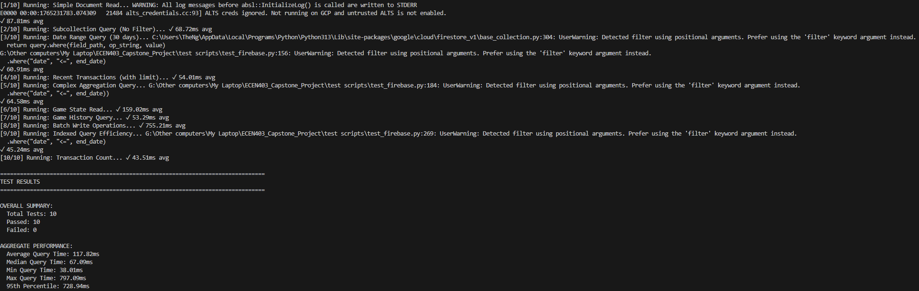

**Figure 12.** Firebase performance test

# Spending Analytics Engine

## Purpose of the Analytics Engine

The Spending Analytics Engine is responsible for converting raw transaction data retrieved from Plaid into meaningful financial insights that support user budgeting, spending awareness, and in-app decision-making. While Plaid provides accurate financial records, these records must be aggregated, categorized, and interpreted before they can be presented to the user in a useful form. The analytics engine fulfills this role by performing server-side computations that summarize user spending behavior and provide structured outputs for the React Native frontend.

The primary objective of the analytics engine is to enable users to understand their financial patterns at a glance. By grouping expenses into high-level categories, calculating total spending for defined time intervals, monitoring changes over time, and determining budget utilization, the engine plays a direct role in improving users’ financial literacy. These insights also support the gamified educational system, where accurate transaction summaries are required for the Financial Categories and Spend Detective games.

Unlike simple client-side rendering, the backend performs analytics using normalized Firestore data to ensure consistency across sessions and across devices. This approach offers several advantages:

* **Data Integrity:** Calculations use the most recent, validated transaction set stored in Firestore.
* **Consistency:** All users receive analytics computed by the same backend logic, reducing display discrepancies.
* **Performance:** Aggregations are computed once per request on the backend, reducing client workload.
* **Scalability:** The backend can easily incorporate additional analytics features as the system evolves.

By transforming low-level transaction data into structured financial insights, the analytics engine serves as the foundation for the application’s budgeting tools, graphical displays, and interactive learning experiences.

## Spending by Category Analytics

Spending by category is one of the core analytical features provided by the backend subsystem. This computation transforms individual transaction records retrieved from Plaid into aggregated category totals that allow users to understand where their money is being spent. The analytics engine groups transactions into standardized high-level spending categories defined by the application, ensuring consistent reporting regardless of the underlying diversity of merchant types and category hierarchies returned by Plaid.

The engine retrieves normalized transaction documents from the user’s Firestore subcollection and filters them according to the requested date range, such as the current month or previous week. Each transaction’s category field, produced during normalization, maps the raw Plaid category array to one of the predefined categories used by the application (e.g., Food, Transportation, Shopping, Entertainment). Transactions with missing or ambiguous categories are assigned to a fallback category such as "Other" to preserve completeness.

Once filtered and grouped, the backend computes the total spending for each category by summing transaction amounts. These aggregated values are returned to the frontend in a structured JSON response that includes:

* Category names
* Total amounts spent in each category
* Percentage contribution of each category to total spending
* Optional unused categories for graph balancing

These results drive the application's pie charts, bar charts, and summary views in the Tracking/Analysis tab. The backend performs the computation server-side to ensure accurate, consistent aggregation that cannot be altered or misinterpreted by client-side logic.

To support scalability, the engine performs only the necessary Firestore reads and uses efficient in-memory aggregation. By grouping transactions during processing rather than storing precomputed totals, the system remains flexible and can easily accommodate new time ranges or custom filters without database restructuring.

## Spending Trends Over Time

The analytics engine also computes spending trends over time, enabling users to observe how their expenses evolve across days, weeks, or months. This functionality provides temporal context that single-interval summaries cannot offer, helping users identify periods of unusually high spending, emerging habits, or progress toward improved financial behavior.

The backend retrieves the user’s normalized transactions from Firestore and groups them by time interval based on the requested granularity. For monthly views, transactions are grouped by day or week; for long-term views, they may be grouped by month. Each transaction contributes its amount to the corresponding time interval bucket.

During trend computation, the backend:

1. **Filters transactions by time range**, such as the past 30 days or the current budgeting period.
2. **Aligns intervals** so that even periods without spending activity appear explicitly, ensuring visual continuity in charts.
3. **Aggregates spending amounts** for each interval, producing a time-indexed dataset.
4. **Sorts results chronologically** to generate trend-ready outputs for the frontend’s visual components.

The resulting dataset is returned as structured JSON, formatted as:

[

{"date": "2025-11-01", "total": 34.87},

{"date": "2025-11-02", "total": 12.50},

{"date": "2025-11-03", "total": 0.00},

...

]

This allows the frontend to construct line charts or bar charts that clearly convey the trajectory of the user’s spending. By computing these trends on the backend, the application ensures consistent analytics across devices and prevents clients from performing potentially expensive data-processing operations on large transaction histories.

The overall design supports extensibility: new time intervals, rolling averages, anomaly detection metrics, or predictive components could be incorporated in the future without altering the underlying storage schema.

## Budget Utilization Calculation

The budget utilization calculation provides users with a quantitative measure of how much of their configured budget has been spent within the current budgeting period. This calculation is essential to the application’s financial-advising functionality, as it enables users to gauge their spending pace relative to their goals and adjust behaviors accordingly.

The backend subsystem retrieves the user’s budget setting from the root Firestore document (users/{uid}) and obtains the corresponding set of normalized transactions for the defined budget window. In most cases, this window aligns with the current calendar month, though the backend can support custom durations if required. The analytics engine then filters the transaction set by date, ensuring that only qualifying expenses contribute to utilization.

Once the filtered transactions are obtained, the backend performs the following computations:

1. **Total Spending:** The engine computes the sum of all amount fields for transactions in the budget window. Pending transactions may be included or excluded depending on configuration, but the backend defaults to excluding pending charges to avoid overstating spending.
2. **Budget Proportion:** The backend divides the total spending by the user’s budget value to determine utilization. This yields a ratio between 0 and 1 (or higher if the user has exceeded their budget).
$utilization=\frac{total spent}{budget}$

3. **Status Classification:** To support UI context, the backend may categorize utilization into qualitative ranges:
   1. **Healthy** (e.g., < 50%)
   2. **Moderate** (50–80%)
   3. **At Risk** (> 80%)
   4. **Exceeded** (> 100%)  
       These classifications are returned to the frontend for display in progress bars and alerts.
4. **JSON Output Formatting:** The backend returns a structured payload, such as:  
     
    {

"budget": 500.00,

"total_spent": 342.75,

"utilization": 0.6855

}

This server-side computation ensures that budget progress is consistent across devices and remains synchronized with the most current set of normalized transactions. Because the analytics engine calculates utilization dynamically, any new transactions retrieved from Plaid immediately update the user’s budget status.

The calculation is also used indirectly in the educational components of the application. Minigames and user progression may reference utilization data to structure personalized challenges or reinforce budgeting concepts.

## Analytics Endpoint Design

The backend subsystem exposes the analytics engine through a set of RESTful API endpoints designed to provide the frontend with structured financial insights on demand. These endpoints retrieve normalized transaction data from Firestore, perform server-side aggregation and filtering, and return the results in standardized JSON formats for visualization in the application's Tracking/Analysis interface. The endpoint design follows principles of modularity, statelessness, and predictable behavior to support scalable integration with the React Native frontend.

Each analytics endpoint is protected by the authentication middleware, requiring a valid Firebase ID token. This ensures that analytics results are computed only for authenticated users and prevents unauthorized access to financial summaries. Once authentication is confirmed, each endpoint retrieves the user’s UID and accesses the appropriate Firestore subcollections to perform the requested computations.

The analytics engine exposes three primary categories of endpoints:

### 1. Spending Summary Endpoints

These endpoints compute total spending for a specified period (e.g., current month, last 7 days). A typical endpoint structure is:

GET /analytics/summary?range=30d

The backend retrieves all transactions within the specified window, computes the total amount spent, and returns a JSON response:

{

"range": "30d",

"total_spent": 342.75

}

This endpoint is used to populate high-level dashboard summaries.

### 2. Spending by Category Endpoints

Category-level analytics are exposed through endpoints such as:

GET /analytics/categories?range=30d

This endpoint aggregates transactions into the application’s high-level categories and returns formatted results:

{

"categories": [

{"category": "Food", "total": 120.45},

{"category": "Transport", "total": 45.90},

{"category": "Shopping", "total": 82.00},

{"category": "Other", "total": 15.32}

]

}

The frontend uses these values to construct pie charts and bar plots.

### 3. Spending Trend Endpoints

Trend data is retrieved via endpoints such as:

GET /analytics/trends?range=30d&interval=daily

The backend groups spending by date, producing a chronological dataset:

[

{"date": "2025-11-01", "total": 34.87},

{"date": "2025-11-02", "total": 12.50},

{"date": "2025-11-03", "total": 0.00}

]

This is used for line and bar charts in the frontend.

# Minigame Engines

## Smart Saver Quiz Engine

The Smart Saver Quiz engine provides a structured, question-based learning experience designed to reinforce fundamental financial literacy concepts. The backend subsystem is responsible for managing the question set, validating user responses, computing per-question outcomes, and awarding experience points (XP) based on performance. This ensures that quiz behavior is consistent across all devices and that user progression is securely tracked in Firestore.

When a user initiates a Smart Saver Quiz session, the frontend sends a request to the backend, which retrieves a predefined set of quiz questions stored within the Smart Saver Quiz module (smart_saver_quiz.py). These questions cover financial topics such as budgeting, interest, saving habits, and general personal finance practices. The backend selects the appropriate question, either sequentially or randomly, depending on the design, and returns both the question prompt and answer options to the frontend in a standardized JSON structure.

When the user submits an answer, the frontend sends their selection to the backend. The Smart Saver Quiz engine then performs three key functions:

1. **Response Validation:** The engine compares the user's selection against the correct answer stored in the question dataset. This validation occurs exclusively on the backend to prevent tampering or client-side guessing.
2. **Feedback Generation:** For each question, the backend returns a correctness flag (true/false) and an explanatory message. This message is intended to reinforce financial knowledge and provide educational context beyond whether the answer is correct.
3. **XP Awarding and Progression Update:** If the user's response is correct, the backend awards XP according to the global progression system. It retrieves the user’s profile from Firestore, increments the xp field, and updates the user’s level if applicable. This write operation uses a merge update to avoid overwriting unrelated profile data.

The Smart Saver Quiz engine includes built-in safeguards to handle missing data, malformed requests, or invalid question identifiers. If any such condition is detected, the backend returns a structured error response and does not modify Firestore.

This design ensures that the Smart Saver Quiz remains secure, consistent, and tightly integrated with the application’s broader learning and progression systems, supporting the project's objective of improving user financial literacy through interactive experiences.



**Figure 13.** Smart Saver Quiz Workflow

## Financial Categories Game Engine

The Financial Categories Game engine is designed to reinforce user understanding of spending categories by challenging them to correctly classify recent transactions. Unlike the Smart Saver Quiz, which uses fixed question sets, this game dynamically generates its content from the user’s actual financial activity retrieved through Plaid and stored in Firestore. This design increases engagement and personal relevance while strengthening the user’s awareness of their spending patterns.

When the frontend initiates a new game session, it sends a request to the backend to retrieve a curated set of recent transactions for the user. The backend selects transactions from the normalized transaction dataset stored in users/{uid}/transactions. These transactions are filtered to include only a meaningful recent window (e.g., the past 7-30 days) and must meet certain criteria such as having non-empty merchant names and associated categories.

The backend then performs the following operations:

1. **Transaction Sampling:** A subset of transactions is selected based on defined rules—for example, selecting 5–10 transactions from recent spending activity. Transactions may be sampled randomly or uniformly to ensure variety.
2. **Category Masking:** For each selected transaction, the backend removes the internal category field before sending it to the frontend. This prevents the client from accessing the correct answer prematurely and ensures that category validation occurs exclusively on the server.
3. **Game Round Formatting:** The backend constructs a standardized JSON object for each transaction containing:
   * Merchant name
   * Amount
   * Date
   * A list of possible category options (e.g., Food, Shopping, Transport, Utilities)
   * A hidden identifier to match responses
4. These options are derived from the application’s global category set.
5. **Answer Validation:** When the user submits their selected category, the frontend sends the identifier and chosen category back to the backend. The backend compares the user’s selection to the true category stored in Firestore, determining whether the answer is correct.
6. **Progression Update:** If the answer is correct, the backend awards XP through the global progression system and updates the user’s XP and level in Firestore. This integrates the game into the educational loop and provides continuous reinforcement.
7. **Game State Tracking:** The backend optionally records gameplay statistics, such as total correct answers or last played timestamp, under the game_state subcollection to support cooldowns and usage analytics.

If the backend detects that the user lacks sufficient transactions to generate a meaningful game session, it returns a structured error response prompting the frontend to notify the user. This prevents the generation of low-quality or repetitive game rounds.

Through dynamic content generation and server-side validation, the Financial Categories Game provides an interactive and personalized learning tool that strengthens the user’s financial categorization skills using authentic transaction data.



**Figure 14.** Financial Categories Workflow

## Spend Detective Game Engine

The Spend Detective Game engine is the most dynamic and algorithmically complex of the minigames implemented in the backend subsystem. Its purpose is to encourage users to review their spending patterns carefully by presenting a mixture of authentic and artificially generated transactions (“anomalies”) and challenging the user to identify which ones do not belong. By integrating real user spending behavior with simulated anomalies, the game reinforces financial vigilance and deeper familiarity with personal expenses.

When a user starts a Spend Detective session, the frontend sends a request to the backend, which retrieves the most recent transactions from the user’s Firestore transaction collection. These transactions are filtered by date to ensure that the game reflects the user’s current financial activity, for example, transactions within the last week. The backend then performs the following operations:

### 1. Selection of Real Transactions

The backend extracts a subset of legitimate transactions based on recency, uniqueness, and merchant diversity. If the user does not have enough recent data to support the game, the backend returns a structured error response, ensuring that the game is only presented when meaningful.

### 2. Anomaly Generation

A defining feature of the Spend Detective engine is its ability to generate realistic, but incorrect, transaction anomalies when the user’s actual dataset contains too few examples. This ensures that the game remains playable even for users with minimal transaction history. Anomalies may vary in merchant name, category, or amount, but they conform to the expected transaction schema so that they blend seamlessly with real entries.

Examples of synthetic anomalies include:

* Inflated or deflated amounts compared to typical user spending
* Merchants not present in the user’s actual transaction history
* Category mismatches (e.g., a grocery-style transaction labeled as Entertainment)

These anomalies are generated deterministically from templates within spend_detective.py, preserving realism while preventing accidental collision with true transactions.

### 3. Game Round Assembly

The game engine constructs a mixed list of transactions containing both real entries and generated anomalies. For each item, the backend masks internal metadata used for validation and instead assigns a game-specific identifier. The response includes:

* Merchant name
* Transaction amount
* Date
* A masked indication that the user must determine whether the item is “real” or “fake”
* A unique item identifier used for result submission

The backend also tracks the total number of anomalies expected for the round.

### 4. User Guess Validation

When a user selects whether a transaction is legitimate or anomalous, the frontend submits their guess to the backend. The backend validates the guess by referencing internal metadata stored temporarily for the current session. If the user is correct, the game increments the count of anomalies found; incorrect guesses decrement the game’s remaining attempts.

The backend enforces strict game progression rules:

* The game ends when the user finds all anomalies or exhausts their attempts.
* Correct guesses **do not** reset attempts.
* Incorrect guesses **do not** reset anomaly counts.

This logic ensures consistent behavior across sessions and devices.

### 5. XP Awarding and Session Finalization

At the end of a round, XP is awarded based on the user’s performance. The backend updates the user’s Firestore profile document, adjusting xp and level through the progression engine. Game completion details (e.g., last_played, win/loss outcome) are written to the game_state subcollection.

### 6. Weekly Lockout Enforcement

To maintain the game’s educational value, the backend restricts the game to one playable session per week. This is enforced by comparing the current timestamp to the last_played timestamp stored under users/{uid}/game_state/spend_detective. If the session occurs within the same 7-day window, the backend returns an appropriate lockout message.



**Figure 15.** Spend Detective Workflow

# Experience & Leveling System

The Progression System provides a unified framework for tracking user advancement across all educational components of the application. It reinforces continued engagement by awarding experience points (XP) for successful minigame interactions and elevating users through defined level thresholds. This system ensures that learning activities have measurable outcomes and are reflected consistently across sessions and devices.

The backend subsystem manages all XP calculations, threshold checks, and level updates. All progression events occur exclusively on the server to preserve integrity and prevent client-side manipulation. When XP is earned, the backend updates the user profile stored under users/{uid}, ensuring secure and persistent tracking of financial learning progress.

The following subsections describe the XP model, the level threshold framework, and how the progression logic integrates with all minigames.

## XP and Level Model

The XP and Level Model defines how users accumulate experience and advance through levels as they engage with the application. Each minigame awards XP based on performance metrics that are tied to educational outcomes.

Typical XP awards include:

* Correct responses in the Smart Saver Quiz
* Correct category selections in the Financial Categories Game
* Successful identification of anomalies in Spend Detective

When an XP award event occurs, the backend retrieves the user’s current XP value from Firestore, adds the awarded amount, and writes the updated total back to the user profile. XP values increase monotonically and cannot be reduced by user actions or invalid submissions.

Levels are derived from cumulative XP. Each level corresponds to a specific XP interval, and leveling up reflects both user progress and increased familiarity with financial concepts. The backend checks for level advancement immediately after XP updates to ensure that the user interface can display timely rewards.

This server-side architecture guarantees that progression is consistent, secure, and immune to client modification.

## Level Threshold Logic

The level threshold logic defines the numeric criteria required for advancing from one level to the next. These thresholds are implemented within the backend progression module and follow a predictable, increasing sequence to maintain user motivation.

**Key Level Milestones:**

* **Level 1:** 0 XP (starting point)
* **Level 10:** 200 XP (~1 week of play)
* **Level 20:** 800 XP (~1 month)
* **Level 30:** 1,800 XP (~2 months)
* **Level 50:** 5,000 XP (~6 months)
* **Level 75:** 11,250 XP (~1 year)
* **Level 100:** 20,000 XP (~2 years, max level)

## Rank Threshold System

**6 Finance-Themed Ranks:**

1. **Penny Pincher** (Starting Rank)
   * Threshold: 0 XP
   * Color: Copper
   * Tier: Bronze
2. **Savvy Saver**
   * Threshold: 500 XP
   * Color: Bronze
   * Tier: Bronze
3. **Budget Master**
   * Threshold: 1,500 XP
   * Color: Silver
   * Tier: Silver
4. **Portfolio Pro**
   * Threshold: 3,500 XP
   * Color: Gold
   * Tier: Gold
5. **Investment Expert**
   * Threshold: 7,000 XP
   * Color: Platinum
   * Tier: Platinum
6. **Finance Legend** (Max Rank)
   * Threshold: 12,000 XP
   * Color: Diamond
   * Tier: Diamond

## Progression Logic

**Level Progression:**

* Uses **square root curve** for smooth, achievable advancement
* Earlier levels require less XP (faster progression initially)
* Later levels require more XP (natural slowing)
* Creates sense of accomplishment without grinding

**Rank Progression:**

* **Linear thresholds** with increasing gaps
* Gap between ranks: 500 → 1,000 → 2,000 → 3,500 → 5,000 XP
* Designed for long-term engagement
* Each rank represents significant achievement

**Progress Tracking:**

* Both level AND rank progress displayed to user
* Progress to next level: (current_xp - xp_for_current_level) / (xp_for_next_level - xp_for_current_level)
* Progress to next rank: (xp_in_current_rank) / (xp_needed_for_next_rank)

**XP Sources:**

* All three minigames award XP to unified system
* Smart Saver Quiz: Awards XP per correct answer
* Spend Detective: Awards XP based on accuracy
* Financial Categories: Awards XP for correct categorizations
* System tracks source of XP for analytics

This threshold system separates educational progression from game difficulty and allows new levels or reward structures to be introduced without restructuring existing user data.

Because the calculation is lightweight and deterministic, it supports real-time updates during gameplay without performance impact.

## Integration with All Minigames

The progression system is deeply integrated with each minigame to ensure that gameplay outcomes translate into measurable financial learning progress.

**Smart Saver Quiz** The backend awards XP for each correct answer submitted. The quiz module triggers progression updates on a per-question basis, enabling immediate reinforcement of financial literacy concepts.

**Financial Categories Game** The backend awards XP when users correctly classify transactions into the appropriate spending categories. This reinforces practical financial skills by connecting XP rewards to accurate spending analysis.

**Spend Detective** At the conclusion of each session, XP is awarded based on anomalies identified and overall performance. The backend applies XP only once per completed session, ensuring fair progression and preventing repeated triggering from partial or invalid submissions.

For all minigames, XP and level updates occur through a shared backend progression function. This design promotes consistency, reduces duplication, and ensures that any future educational modules can integrate seamlessly with the existing progression framework.

# API Design and Backend Endpoints

## Endpoint List

The backend exposes a set of REST endpoints that are grouped into four logical domains: health and test, Plaid bank integration, analytics, and minigames. All application endpoints under /api/* are protected by the Firebase authentication middleware, with the exception of the public health and test utilities.

Tables 11.1 through 11.4 summarize the primary endpoints that are used by the mobile frontend in the final system.

| **Path** | **Method** | **Auth Required** | **Description** |
| --- | --- | --- | --- |
| /api/health | GET | No | Basic health check for the Flask backend. |
| /api/test/routes | GET | No | Returns a list of all registered routes. |
| /api/test/echo | POST | No | Echoes request body for connectivity verification. |

**Table 1.** Health and Utility Endpoints

| **Path** | **Method** | **Auth Required** | **Description** |
| --- | --- | --- | --- |
| /api/plaid/create_link_token | POST | Yes | Creates a Plaid Link token for the authenticated user. |
| /api/plaid/exchange_public_token | POST | Yes | Exchanges a Plaid public token for a long lived access token. |
| /api/plaid/transactions/sync | POST | Yes | Retrieves recent transactions from Plaid and updates Firestore. |
| /api/plaid/status | POST | Yes | Returns whether the user has an active Plaid connection and last sync time. |
| /api/plaid/sandbox/instant_item | POST | Yes | (Testing only) Creates a sandbox item and public token on the backend. |
| /api/plaid/webhook/... | POST | No (Plaid) | Receives Plaid webhooks for item and transaction updates. |

**Table 2.** Plaid Bank Integration Endpoints

| **Path** | **Method** | **Auth Required** | **Description** |
| --- | --- | --- | --- |
| /api/analytics/budget/progress | GET | Yes | Returns budget utilization metrics for the current period. |
| /api/analytics/spending/by-category | GET | Yes | Returns spending totals grouped by high level category. |
| /api/analytics/spending/over-time | GET | Yes | Returns time series spending data for charts. |
| /api/analytics/transactions/recent | GET | Yes | Returns a small set of the most recent transactions for display. |
| /api/aggregate-spend | GET | Yes | Aggregate spending summary used by earlier analytics views. |
| /api/spend-forecast | GET | Yes | Experimental forecast of future spending based on recent history. |
| /api/trend-summary | GET | Yes | High level summary of spending trends over the selected window. |

**Table 3.** Analytics Endpoints

| **Path** | **Method** | **Auth Required** | **Description** |
| --- | --- | --- | --- |
| /api/minigame/financial-categories/start | POST | Yes | Starts a Financial Categories round using recent transactions. |
| /api/minigame/financial-categories/match | POST | Yes | Submits the user’s category choices and returns correctness and XP. |
| /api/minigame/spend-detective/start | POST | Yes | Starts a Spend Detective round and returns mixed real and anomaly items. |
| /api/minigame/spend-detective/select | POST | Yes | Records user selections during a Spend Detective round. |
| /api/minigame/spend-detective/submit | POST | Yes | Finalizes a Spend Detective round, resolves results, and awards XP. |
| /api/minigame/spend-detective/submit-guess | POST | Yes | Newer endpoint for per guess validation in Spend Detective. |
| /api/minigame/spend-detective/state | GET | Yes | Returns current Spend Detective state, including weekly lock status. |
| /api/minigame/quiz/new | POST | Yes | Starts a new Smart Saver Quiz set and returns initial questions. |
| /api/minigame/quiz/answer | POST | Yes | Validates a single quiz answer and awards XP if correct. |
| /api/minigame/quiz/submit | POST | Yes | Legacy batch submission endpoint kept for backward compatibility. |
| /api/minigame/quiz/state | GET | Yes | Returns quiz streak, difficulty, and current quiz state for the user. |
| /api/minigame/stats | GET | Yes | Returns a combined view of progression and minigame status. |

**Table 4.** Minigame Service Endpoints

## Request and Response Examples

This subsection illustrates how the frontend interacts with the backend API through representative requests and responses. All authenticated endpoints expect a Firebase ID token in the Authorization header and return JSON-encoded payloads. The examples below use three core flows:

1. Plaid transaction synchronization
2. Spending analytics retrieval
3. Minigame interaction

These examples can be reproduced using Postman or curl and are good candidates for screenshots in the final report.

## Plaid Transaction Synchronization Example

**Endpoint:** POST /api/plaid/transactions/sync

**Headers:**

Authorization: <firebase-id-token>

Content-Type: application/json

**Request body:**

{

"start_date": "2025-11-01",

"end_date": "2025-11-30"

}

**Sample success response:**

{

"status": "success",

"synced_count": 32,

"new_transactions": 18,

"updated_transactions": 14,

"last_sync": "2025-11-30T21:05:43Z"

}

This response indicates that the backend contacted Plaid, retrieved transactions for the requested period, normalized them, and updated Firestore.

### Spending by Category Analytics Example

**Endpoint:** GET /api/analytics/spending/by-category?range=30d

**Headers:**

Authorization: <firebase-id-token>

**Sample response:**

{

"range": "30d",

"total_spent": 342.75,

"categories": [

{ "category": "Food", "total": 120.45, "percent": 35.1 },

{ "category": "Transport", "total": 45.90, "percent": 13.4 },

{ "category": "Shopping", "total": 82.00, "percent": 23.9 },

{ "category": "Other", "total": 94.40, "percent": 27.6 }

]

}

The frontend uses this response to generate pie charts and summary cards in the Tracking and Analysis tab.

### Spend Detective Game Start Example

**Endpoint:** POST /api/minigame/spend-detective/start

**Headers:**

Authorization: <firebase-id-token>

Content-Type: application/json

**Request body:**

{

"max_items": 10

}

**Sample response when a game can be started:**

{

"status": "ready",

"total_items": 8,

"expected_anomalies": 3,

"items": [

{

"id": "g1",

"merchant_name": "Coffee Corner",

"amount": 4.75,

"date": "2025-11-28"

},

{

"id": "g2",

"merchant_name": "Gamma Electronics",

"amount": 412.99,

"date": "2025-11-27"

}

]

}

Each item in the items list is either a real transaction or a generated anomaly. The internal labels are stored only on the backend, and the frontend asks the user to mark each item as real or fake.

**Sample response when not enough data is available:**

{

"status": "error",

"error": "not_enough_data",

"message": "There are not enough recent transactions to start Spend Detective."

}

### Smart Saver Quiz Answer Example

**Endpoint:** POST /api/minigame/quiz/answer

**Headers:**

Authorization: <firebase-id-token>

Content-Type: application/json

**Request body:**

{

"question_id": "q_07",

"selected_option": 2

}

**Sample response:**

{

"correct": true,

"explanation": "Building an emergency fund helps cover unexpected expenses without using high interest debt.",

"awarded_xp": 10,

"new_xp_total": 130,

"new_level": 3

}

This response is used by the frontend to show immediate feedback and update the visible XP or level indicators.

## Error Codes & Standardized Responses

The backend uses a unified error response format across all API routes to ensure that the frontend receives predictable, machine-readable failure messages. This standardization improves maintainability, simplifies debugging, and allows the frontend to gracefully handle errors such as authentication failures, missing request parameters, Plaid API issues, and Firestore access problems.

All errors follow a consistent JSON structure:

{

"status": "error",

"error": "<error_code>",

"message": "<human_readable_message>"

}

The error_code field is a short identifier that the mobile frontend can use for conditional handling, while the message field provides context suitable for user display or debugging.

The backend is designed to avoid exposing internal details such as stack traces, Plaid secrets, or file paths. This protects both user privacy and application security.

### Common Error Codes

| **Error Code** | **HTTP Status** | **Description** |
| --- | --- | --- |
| missing_auth | 401 | Request did not include a Firebase ID token. |
| invalid_auth | 401 | Firebase token is invalid or expired. |
| missing_parameter | 400 | Required field was not included in the request body. |
| plaid_token_invalid | 400 | Plaid public token could not be exchanged for an access token. |
| plaid_request_failed | 500 | A request to Plaid failed for an unexpected reason. |
| not_enough_data | 400 | User does not have sufficient recent transactions for the minigame. |
| firestore_error | 500 | Firestore read or write operation failed. |
| game_invalid_state | 400 | User attempted to play a game without a valid session state. |
| weekly_lockout | 403 | Spend Detective is already completed for the current week. |
| unknown_error | 500 | Catch all server error. |

**Figure 5.** Standard Backend Error Codes

### Example Error Response: Missing Authentication

**Request:** GET /api/analytics/spending/by-category

**Headers:** None

**Response:**

{

"status": "error",

"error": "missing_auth",

"message": "A valid Firebase ID token is required."

}

This response is generated by the authentication middleware before the route logic executes.

### Example Error Response: Invalid Plaid Token

**Request body:**

{

"public_token": "invalid123"

}

**Response:**

{

"status": "error",

"error": "plaid_token_invalid",

"message": "The provided Plaid public token is not valid."

}

This validates backend protection against malformed or spoofed public tokens.

### Example Error Response: Not Enough Data for Spend Detective

**Response:**

{

"status": "error",

"error": "not_enough_data",

"message": "There are not enough recent transactions to start Spend Detective."

}

This is returned when the game cannot be meaningfully generated.

## Middleware Usage

The backend subsystem uses middleware to enforce authentication, validate request structure, and ensure consistent preprocessing before any application logic executes. Middleware is applied at the route level and is responsible for guaranteeing that every request entering the backend contains a valid Firebase authentication token and that the authenticated user's UID is available to the route handler.

The primary middleware component is the Firebase authentication verifier. This function inspects the Authorization header, extracts the Firebase ID token, and verifies it using Firebase Admin SDK. If the token is valid, the middleware attaches the decoded UID to the request context. If the token is missing or invalid, the middleware terminates the request early and returns a standardized JSON error response with an HTTP 401 status code.

This design protects all sensitive API routes, including Plaid integration, analytics endpoints, and minigame services. Because authentication logic is centralized in one module, every subsystem behaves predictably without duplicating credential checks in each route. This improves maintainability and reduces the likelihood of inconsistencies or security oversights.

In addition to authentication, the middleware layer also provides a clean abstraction for future preprocessing tasks. Examples include optional request body validation, logging hooks, and throttling logic. Although these features are not required in the current system, the middleware architecture allows them to be added without refactoring the core backend logic.

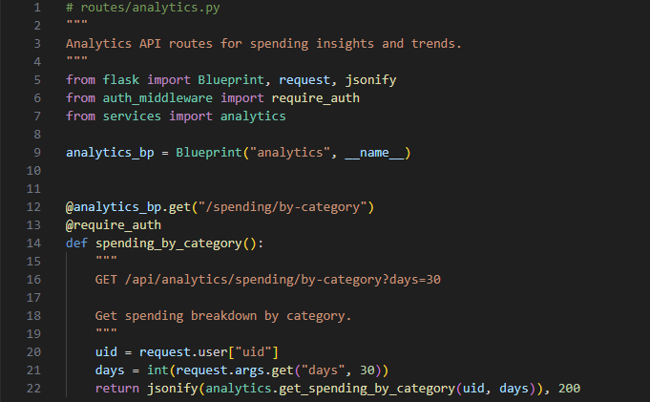

**Figure 16.** Route endpoints for analytics

Financial Advisor App for Students

Camille Embree, Hoang-Nghi Nguyen

**System Report**

**Table of Contents**

**List of Figures 62**

**1****. Overview 64**

**2****. Development Plan and Execution 65**

2.1. Design Plan 65

2.2. Execution 66

2.3. Validation Plan 69

**3****. System Data and Validation 85**

3.1. Transaction Data 85

3.2. Analytics Output 86

3.3. Minigame State Data 89

3.4. Progression Data

**4. Conclusion**

4.1. Key Decisions 89

4.2. Learnings

4.3. Future Work

**List of Figures**

**Figur****e 1.** Transactions pulled from firebase user 147

**Figure 2.** Analytics displayed from user data 148

**Figure 3.** Minigame States and Plays 149

**Figure 4.** Progression system and minigame menu 150

# Overview

The Personalized Financial Advisor System is a mobile application designed to provide students with an accessible, automated, and engaging way to understand and manage their finances. The final integrated system is composed of five main subsystems: the mobile frontend application, the backend server, the Firebase authentication and database layer, the Plaid financial data integration module, and the interactive minigame engine. Each subsystem contributes functionality that, when combined, forms a cohesive financial management platform capable of retrieving real-time bank transactions, analyzing spending behavior, visualizing trends, and reinforcing financial literacy through gamified learning.

The system’s architecture emphasizes automation and usability. Instead of relying on users to manually input or scan receipts, the app retrieves verified financial data directly from the user’s linked bank accounts. This data is then normalized, stored securely, and processed through the backend analytics engine to generate insights about spending categories, budget utilization, and behavioral trends. These insights feed into both the user-facing dashboards and the educational minigames, aligning the system’s financial intelligence with intuitive user experiences.

The development of the system required close coordination between all subsystems to ensure correctness, security, and consistency. The backend integrates with Plaid and Firebase, performs data transformation, and manages authentication, while the frontend displays results, handles user interactions, and presents game logic to the user. The final integrated system demonstrates reliability, responsiveness, and scalability while maintaining secure handling of sensitive financial information.

Upon completion of integration and validation, the Personalized Financial Advisor System represents a fully functional financial education platform built for real-world usage by students seeking to improve their budgeting discipline and financial literacy.

# Development Plan and Execution

## Design Plan

The design plan for the Personalized Financial Advisor System originated from the goal of creating a fully automated financial management tool that required minimal user input and delivered meaningful financial insights. The early conceptual design from the previous semester centered on receipt scanning and machine learning classification. However, the original approach was constrained by limited dataset quality, inconsistent receipt formats, and the operational challenges associated with training and maintaining OCR and classification models. These limitations prompted a significant architectural redesign that shaped the final system presented in this report.

The updated design plan prioritized reliability, scalability, and user experience. Instead of depending on manually scanned receipts, the system now retrieves accurate financial data directly from user bank accounts through the Plaid API. This change allowed the team to eliminate unnecessary user friction, significantly improve data consistency, and ensure that financial insights are grounded in verified banking transactions. The adoption of Plaid also aligned the system more closely with real-world financial applications and industry practices.

The selection of technologies followed naturally from the system objectives. React Native was chosen for the frontend to allow rapid mobile UI development and cross-platform compatibility. Firebase Authentication was selected to provide secure and scalable user management without requiring custom credential storage. Firestore, Firebase’s NoSQL database, was adopted to store normalized transactions, user profiles, and minigame state data in a flexible and hierarchical structure that supports incremental feature expansion.

On the backend, Flask was chosen to support a lightweight, modular API that exposes analytics, minigame logic, Plaid integration, and authentication middleware. The backend is deployed on Google Cloud Run to achieve statelessness, containerized execution, and automatic scaling without server maintenance. The final design incorporates a clear data flow: Plaid provides raw transaction records, the backend normalizes and stores them, Firebase persists the data, and the frontend retrieves insights and interactive experiences through well-defined REST endpoints.

The design plan also introduced a dedicated minigame subsystem to reinforce financial literacy through active learning. The minigames were designed to operate on real user spending data and to integrate with a progression system that awards experience points and levels. This approach transformed the application from a passive financial tracker into an educational tool that encourages engagement and habit-building.

Overall, the design plan established a modular architecture in which each subsystem is independently testable yet integrated into a cohesive end-to-end financial advisory platform. The plan provided the foundation for the system’s development, guiding the team’s technical decisions and ensuring that the final product aligned with the project objectives.

## Execution

The execution of the Personalized Financial Advisor System followed an iterative development process in which the backend, frontend, and database subsystems were implemented in parallel and progressively integrated. Development began with foundational components such as authentication, API routing, and database structure, and later transitioned into complex features including Plaid integration, analytics computation, and minigame engines. Throughout execution, the team focused on ensuring that each subsystem functioned reliably on its own before being incorporated into the full system.

Backend development began with the creation of the authentication middleware responsible for verifying Firebase ID tokens on every protected route. This middleware established the security model for the system and enabled authenticated API calls without requiring user identifiers in the request body. Once authentication was operational, the Plaid integration module was implemented, beginning with sandbox Link token creation, public token exchange, and access token storage. Transaction synchronization was then developed, including retrieval from Plaid, normalization of transaction records, and idempotent updates to Firestore.

With these core data flows established, development progressed to the analytics engine. Server-side computation functions were created to aggregate spending by category, compute time-series spending trends, and evaluate budget utilization relative to the user’s configured monthly budget. These analytics were exposed through dedicated API endpoints and validated using both synthetic and real financial data retrieved from Plaid’s sandbox. The team ensured that analytics remained consistent across repeated synchronizations and multiple test users.

Minigame development occurred concurrently with analytics integration. The Smart Saver Quiz engine was implemented first due to its static question set and predictable structure. The Financial Categories Game was then developed to operate on normalized transactions, requiring careful validation of category mapping logic. The Spend Detective Game, the most complex of the minigames, was implemented last and required dynamic anomaly generation, session tracking, weekly lockout enforcement, and round-by-round validation logic. Each minigame was integrated with the progression system, which awards experience points and manages level advancement.

Frontend development was executed in parallel to backend feature creation. The team developed a React Native navigation structure composed of a Home tab, Analysis tab, Minigame hub, and Account page. The frontend also integrated the Plaid Link SDK, enabling users to securely connect their bank accounts. Screens and components were created to visualize analytic results, display minigame prompts, and reflect XP and level progression. The frontend interacted with the backend exclusively through authenticated REST calls, ensuring security and data consistency.

Integration was performed iteratively as backend endpoints became available. Initial integration focused on user login and Plaid Link functionality, followed by analytics rendering and finally minigame interactivity. During this phase, several issues related to token expiration, CORS handling, and asynchronous frontend state management were identified and resolved. Frequent testing using real Plaid sandbox accounts ensured stable and predictable system behavior.

Deployment to Google Cloud Run marked the final execution stage. Containerization ensured consistent runtime environments, and environment variables were configured to securely store Plaid and Firebase credentials. Logging and error handling were refined to ensure clear debugging information during operation. After deployment, full system tests confirmed that the system met responsiveness requirements, maintained stable database interactions, and correctly synchronized financial data across all components.

Overall, execution followed a disciplined and structured process that enabled the team to develop, integrate, and validate a feature-complete financial advisory system within the project timeline.

## Validation

The validation plan for the Personalized Financial Advisor System was developed to ensure that the final integrated platform meets its functional, performance, and usability requirements. The plan establishes clear success criteria, test methods, and responsibilities for each subsystem, and it verifies system correctness from isolated backend components to full end-to-end user interactions. Validation activities occurred throughout development, with final verification completed after backend deployment to Google Cloud Run and full frontend-backend integration.

Validation was structured into three major categories: backend performance and correctness, analytics accuracy, and minigame functionality. Backend validation focused on API responsiveness, Plaid transaction retrieval, data normalization, and Firestore read and write performance. These tests ensured that the system could retrieve financial data reliably, maintain responsive interactions under normal load, and store data consistently in the database. The test procedures included repeated API calls, simulated sandbox conditions using Plaid’s testing environment, and concurrent Firestore operations to verify timing thresholds and identify potential bottlenecks.

Analytics validation confirmed that the backend correctly categorized transactions, aggregated category-level spending, computed time-series trends, and calculated budget utilization. Outputs from the analytics endpoints were compared to manual calculations to ensure accuracy. Additional validation ensured that categorized data was stored correctly in Firestore and displayed accurately on the frontend, enabling the system to provide meaningful financial insights to users.

The minigame subsystem underwent comprehensive functional validation, including both backend logic and frontend interaction. Each game was tested to ensure stable operation, correct scoring, and seamless progression updates. The Smart Saver Quiz validation confirmed correct answer checking and XP awarding. The Financial Categories Game was evaluated based on the accuracy of category validation and the clarity of prompts. The Spend Detective Game underwent the most extensive validation due to its dynamic mixture of real and synthetic transactions, validation logic, attempt tracking, and weekly lockout enforcement. For all games, validation verified that game sessions could be completed without crashes, incorrect state transitions, or authentication errors.

User interface validation focused on frontend usability and visual correctness. Screens such as the Home tab, Tracking and Analysis tab, Account page, and Minigames hub were assessed for accessibility, clarity, and responsiveness. The frontend was validated by groups of students who interacted with the application to confirm that financial insights were clear, navigation was intuitive, and minigame results were displayed accurately.

Frontend-backend integration validation ensured that data flowed correctly from Plaid to the backend, into Firestore, and ultimately into the frontend UI. Integration tests simulated complete user journeys, including linking a bank account, synchronizing transactions, viewing analytics, and completing minigames. These tests confirmed that authentication was enforced correctly, backend responses adhered to the defined API schemas, and frontend screens updated dynamically upon receiving new data.

Overall, the validation plan ensured that every component of the system met the functional expectations described in the requirements and that the integrated system behaved reliably in real usage scenarios.

# System Data and Validation

## Transaction Data

**Figure 1.** Transactions pulled from firebase user

## Analytics Output

The graph outputs for the analytics provided by the backend server computation can be found below and are discussed further under section ***2.3*** of the Frontend Subsystem Report (pg. 64).

## 

## 

## 

## 

## 

## 

## 

## 

## 

## 

## 

## 

## 

## 

**Figure 2.** Analytics displayed from user data

## Minigame State Data

The output of each of the three minigames can be seen below and are discussed in depth in section ***2.4*** of the frontend subsystem report (pg. 66).

## 

## 

## 

## 

## 

## 

## 

## 

## 

## 

## 

## 

## 

## 

**Figure 3.** Minigame States and Plays

## Progression Data

XP data is called from the backend storage system and output on the game hub tab. The UI display of live data can be seen below. The information is updated live, as soon as a user completes a minigame, and the trophy status is moved up accordingly.



# 

# 

# 

# 

# 

# 

# 

# 

# 

**Figure 4.** Progression system and minigame menu

# Conclusion

## Key Decisions

The development of the Personalized Financial Advisor System required several major design decisions that shaped the functionality, scalability, and reliability of the final product. These decisions guided the evolution of the system from its early concept into a fully integrated mobile financial advisory platform. The most significant decisions are summarized below.

The first critical decision was the transition away from a receipt-based pipeline toward a bank data driven architecture using the Plaid API. Early prototypes relied on optical character recognition and machine learning to extract data from receipts. However, variability in receipt formats, inconsistent image quality, and the overhead of maintaining OCR and classification models made this approach impractical. Integrating Plaid provided structured, accurate financial data with minimal user effort, thereby greatly improving system usability and enabling more consistent analytics and gameplay.

A second key decision was the adoption of Firebase Authentication and Firestore as the central identity and data management layer. Firebase ensured secure, token based user authentication without requiring a custom credential system. Firestore provided a flexible NoSQL database that supported hierarchical user data, transaction storage, minigame state, and progression tracking. This choice simplified backend development and enabled the system to scale naturally with user activity.

Another major decision involved the deployment architecture. Early development used local testing environments, but the final system required a reliable, cloud based backend. Deploying the Flask backend to Google Cloud Run allowed the system to benefit from containerized execution, automatic scaling, and increased resilience. The stateless design of Cloud Run instances also aligned well with Firestore’s centralized storage model.

The decision to implement three distinct educational minigames represented a strategic enhancement to the system’s value. The Smart Saver Quiz, Financial Categories Game, and Spend Detective each target different aspects of financial literacy and user behavior. Integrating these minigames with a unified experience point and leveling system provided a cohesive educational framework that encourages long term engagement.

Finally, the decision to centralize transaction normalization and analytics in the backend contributed significantly to system consistency. By ensuring that categorization, trend analysis, and budget evaluations all occur server side, the system eliminates discrepancies across devices and maintains reliable financial insights. This design choice also allows analytic features to evolve independently of frontend updates.

Together, these decisions enabled the team to build a robust financial advisory application that is secure, scalable, and engaging for users. Each choice contributed to the final integrated system and shaped the project’s successful outcome.

## Learnings

The development of the Personalized Financial Advisor System provided the team with substantial experience in full-stack mobile application design, system integration, cloud deployment, and third-party API management. Several key learnings emerged throughout the project, shaping both the technical implementation and the team’s understanding of modern financial software development.

One of the most significant learnings was the complexity involved in processing financial data securely and consistently. Integrating Firebase Authentication required a deep understanding of token verification, user identity mapping, and middleware design. Ensuring that backend routes were protected from unauthorized access emphasized the importance of implementing stateless authentication and validating user permissions on every request. This experience reinforced the need for robust security practices in applications that interact with sensitive financial information.

Another major learning came from working with Plaid’s API. The team developed an appreciation for third-party financial integrations, including the requirements for secure token exchange, handling rate limits, supporting sandbox testing, and managing error responses. Early assumptions about Plaid’s simplicity were corrected as the team navigated multi-step authentication flows and detailed transaction structures. This experience improved the team’s ability to interpret external documentation, troubleshoot integration issues, and design backend logic that tolerates temporary upstream failures.

The project also emphasized the importance of data modeling and consistency. Designing Firestore schemas that support both analytics computation and minigame functionality required careful planning. The team learned how to structure NoSQL data in a way that supports efficient queries, clean normalization, and predictable behavior under concurrent updates. These lessons were reinforced when debugging categorization mismatches, transaction duplication, or inconsistent state data from early minigame prototypes.

From a backend development perspective, the team learned how to build modular, maintainable systems with clear separation of concerns. The implementation of minigame engines, analytics pipelines, and the progression system highlighted the value of isolating business logic from request handling. This separation simplified testing, improved readability, and enabled new features to be added without disrupting existing functionality.

On the frontend, the team gained experience working with asynchronous data flows, state management, and integration of mobile SDKs such as Plaid Link. Several challenges related to navigation, rerendering, and conditional UI updates provided opportunities to deepen frontend development skills and strengthen understanding of how mobile interfaces interact with backend data.

Finally, the process of deploying the backend to Google Cloud Run produced valuable lessons in containerization, environment variable management, and cloud logging. Monitoring real deployment behavior revealed issues that were not visible in local testing, such as cold-start response times, network latency variations, and runtime configuration mismatches. Addressing these challenges improved the reliability and performance of the deployed system.

Collectively, these learnings reflect the breadth of technologies and engineering practices involved in delivering a secure, scalable, and user-friendly financial advisory platform. The experience gained prepares the team for future work in cloud-based services, financial technology applications, and full-stack system development.

## Future Work

Although the Personalized Financial Advisor System meets its core functional objectives and operates as a fully integrated financial tracking and educational platform, several opportunities exist for future enhancements that would expand system capabilities, improve user engagement, and strengthen long-term scalability. These potential developments focus on increasing automation, improving personalization, and extending the system’s educational value.

A primary area for future work is the integration of machine learning–based financial forecasting and behavioral analysis. While the current system provides accurate categorization and spending insights, predictive models could offer users more advanced guidance, such as anticipated monthly spending, projected budget overruns, anomaly detection in financial patterns, or personalized recommendations. Incorporating ML pipelines would also enable adaptive difficulty tuning across minigames based on a user’s spending behavior and performance history.

Another potential improvement involves expanding the analytics engine to incorporate multi-month trend analysis, savings rate estimation, and customizable financial goals. These enhancements would allow users to track long-term changes in their financial habits rather than viewing their spending in isolated monthly intervals. Goal tracking features, such as saving targets or debt reduction milestones, could further support sustained financial improvement.

Minigame expansion represents another promising direction. New games could be introduced to teach additional financial literacy concepts such as credit management, investment basics, or interest calculations. Existing minigames could be extended with additional difficulty levels, randomized question pools, and deeper integration with the progression system. A rewards system that includes badges, streaks, or unlockable content may also enhance long-term user engagement.

Future work may also involve improving the real-world applicability of the system by supporting additional financial institutions, incorporating account types beyond checking and savings, and enabling multi-account analytics. Enhancing the robustness of Plaid integration, including real-time transaction updates or webhook-driven synchronization, would reduce latency and provide a more seamless user experience.

On the technical side, migrating backend services toward microservice architecture or event-driven pipelines could improve scalability as the user base grows. Implementing automated CI/CD flows, unit test suites, and broader monitoring instrumentation would further enhance system maintainability. Additional improvements to error handling, rate limiting, and resilience against upstream failures (such as Plaid outages) would increase overall reliability.

Finally, expanding the user experience to include push notifications, budgeting reminders, or personalized weekly summaries would strengthen the educational value of the platform and encourage consistent engagement. These features would allow the system to act as an active financial advisor rather than a passive analytics tool.

Overall, the system provides a stable and functional foundation for financial tracking and education, and it supports numerous avenues for continued development. Future work can build on the established architecture to deliver a more intelligent, engaging, and comprehensive financial wellness platform.